**Name Priyanka Marandi**

**Roll No. BTECH/60094/19**

**Computerization of BIT Mesra , Deoghar**

**NAMES OF MODULES**

* **Computer Science and Engineering Department**
* **Club Society Department**
* **Girl’ s Hostel Department**
* **Examination Department**

**MODULE 1: COMPUTER SCIENCE & ENGINEERING DEPARTMENT**

**#REQUIREMENTS**

* **Requirement 1: CSE Team**
* **Requirement 2: Total number of students registered**
* **Requirement 3: Students Detail**
* **Requirement 4: Course Structure**
* **Requirement 5: Total credits per semester**
* **Requirement 6: Faculty portal**
* **Requirement 7: Student portal**
* **Requirement 8: Timetable**
* **Requirement 9: faculty advisory portal**
* **Requirement 10: Minor projects portal**
* **Requirement 11: Achievement portal**
* **Requirement 12: Convey segment**
* **Requirement 13: Induction program portal**
* **Requirement 14: Student result portal**
* **Requirement 15: Virtual notice board portal**
* **Requirement 16: Grievance section**

**#FUNCTIONAL REQUIREMENT**

* **Requirement 1: CSE Team**

**Description: this portal will have the detail of department of teachers, staff, lab assistant. It will have complete detail of teacher like phone number, institute email ID etc.** **This will be useful only for teachers use only.**

* **Requirement 2: Total number of students registered**

**Description: This portal will have number of students applied for computer science and engineering. It will have all the document PDF of previous schooling (i.e., migration certificate, 12th board admit card and answer sheet, character certificate, school leaving certificate and many more). This will also have the subject opt by the student and degree which he wants to pursue.** **This will be useful only for teachers use only.**

* **Requirement 3: Student Detail**

**Description: This following portal will have all the details of student like student’s full name, parents name, address, what’s app number, institute email ID. This portal will be applicable for student use.**

* **Requirement 4: Course Structure**

**Description: This following portal will have the semester-wise subject that students have to study. This will also include lecture as well as sessional subject. This will be useful only for teachers use only.**

* **Requirement 5: Total credit per semester**

**Description: this portal will have the semester-wise subject with the weightage of marks per subject. This will be useful only for teachers use only.**

* **Requirement 6: Faculty Portal**

**Description: This portal will have all the requirement for** **teachers like syllabus of the following subject, syllabus of lab subject, subject book as well as reference book, attendance sheet of student.** **This will be useful only for teachers use only.**

* **Requirement 7: Student Portal**

**Description: This portal will have all the requirement for students like syllabus of the following subject, syllabus of lab subject, subject book as well as reference book, monthly attendance sheet, notes.**

* **Requirement 8: Timetable**

**Description: This portal will have all the daily routine work for student as well as teachers. This will also show the time schedule of examination to be held as per semester.**

* **Requirement 9: Faculty advisory Portal**

**Description: this following portal will provide a communication between student and their faculty advisory. This portal is to help student to communicate directly to his/her advisory. Where they can share and solve all sorts of problem regarding institute whether it is personal institute matter or study matter.**

* **Requirement 10: Minor project Portal**

**Description: This portal will have all the previous record of project which passed year student have performed in their academic time for reference. This portal will also have all the question/ topic in which student can prepare a project so that it will be beneficial for campus placement.**

* **Requirement 11: Achievement Portal**

**Description: This following portal will have all the records of student who have achieved extra honor other than academic award like representing institute in another institutional activities.**

* **Requirement 12: convey segment**

**Description: This portal is mainly for both teachers and students where they can communicate to each other. This portal will also help for student where they can clear all their doubt, teachers can share extra notes to student.**

* **Requirement 13: Induction Program Portal**

**Description: This following portal will have all the recorded videos as well as live video from the spoke person from various department. This will also have schedule for all the upcoming webinar.**

* **Requirement 14: Student result Portal**

**Description: this will have the complete PDF result of student per semester-wise.**

* **Requirement 15: Virtual notice board**

**Description: This portal will have an online facilities of emergency notice to the students. Also, this will bring up all the new updates regarding academic.**

* **Requirement 16: Grievance Portal**

**Description: this portal will have the right where student can put their grievance regarding institutional activities.**

**#USE CASE DIAGRAM**

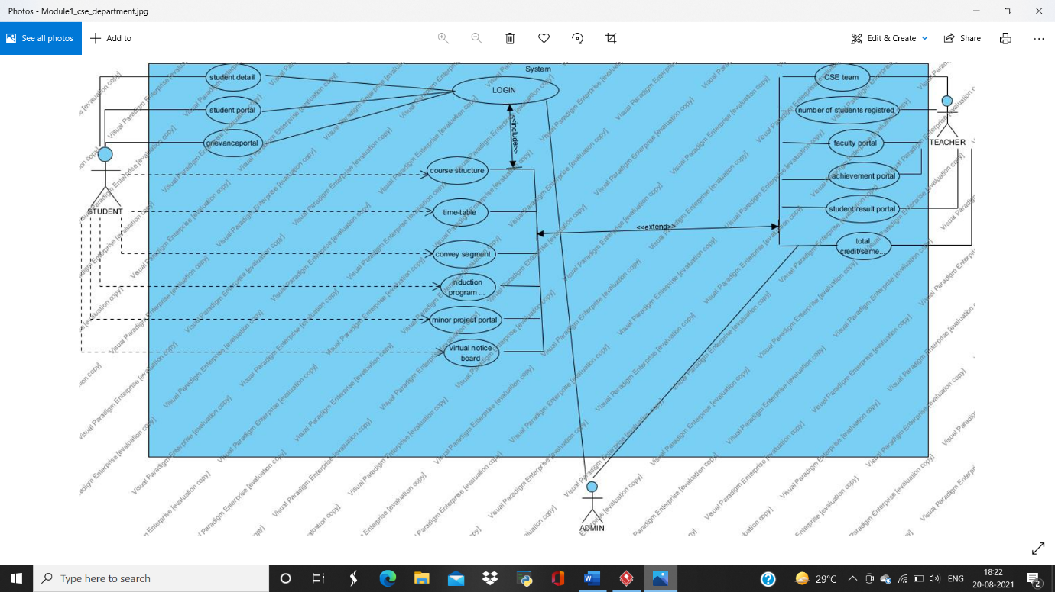

**#ACTIVITY DIAGRAM**

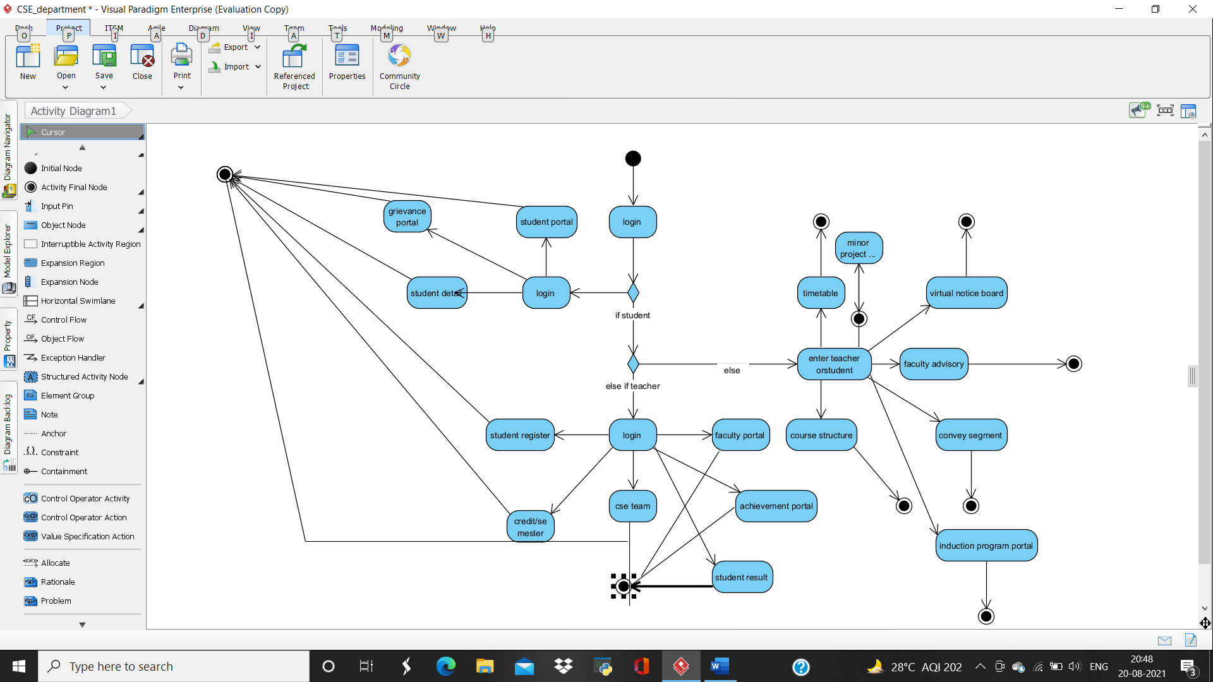

* **ACTIVITY 1**

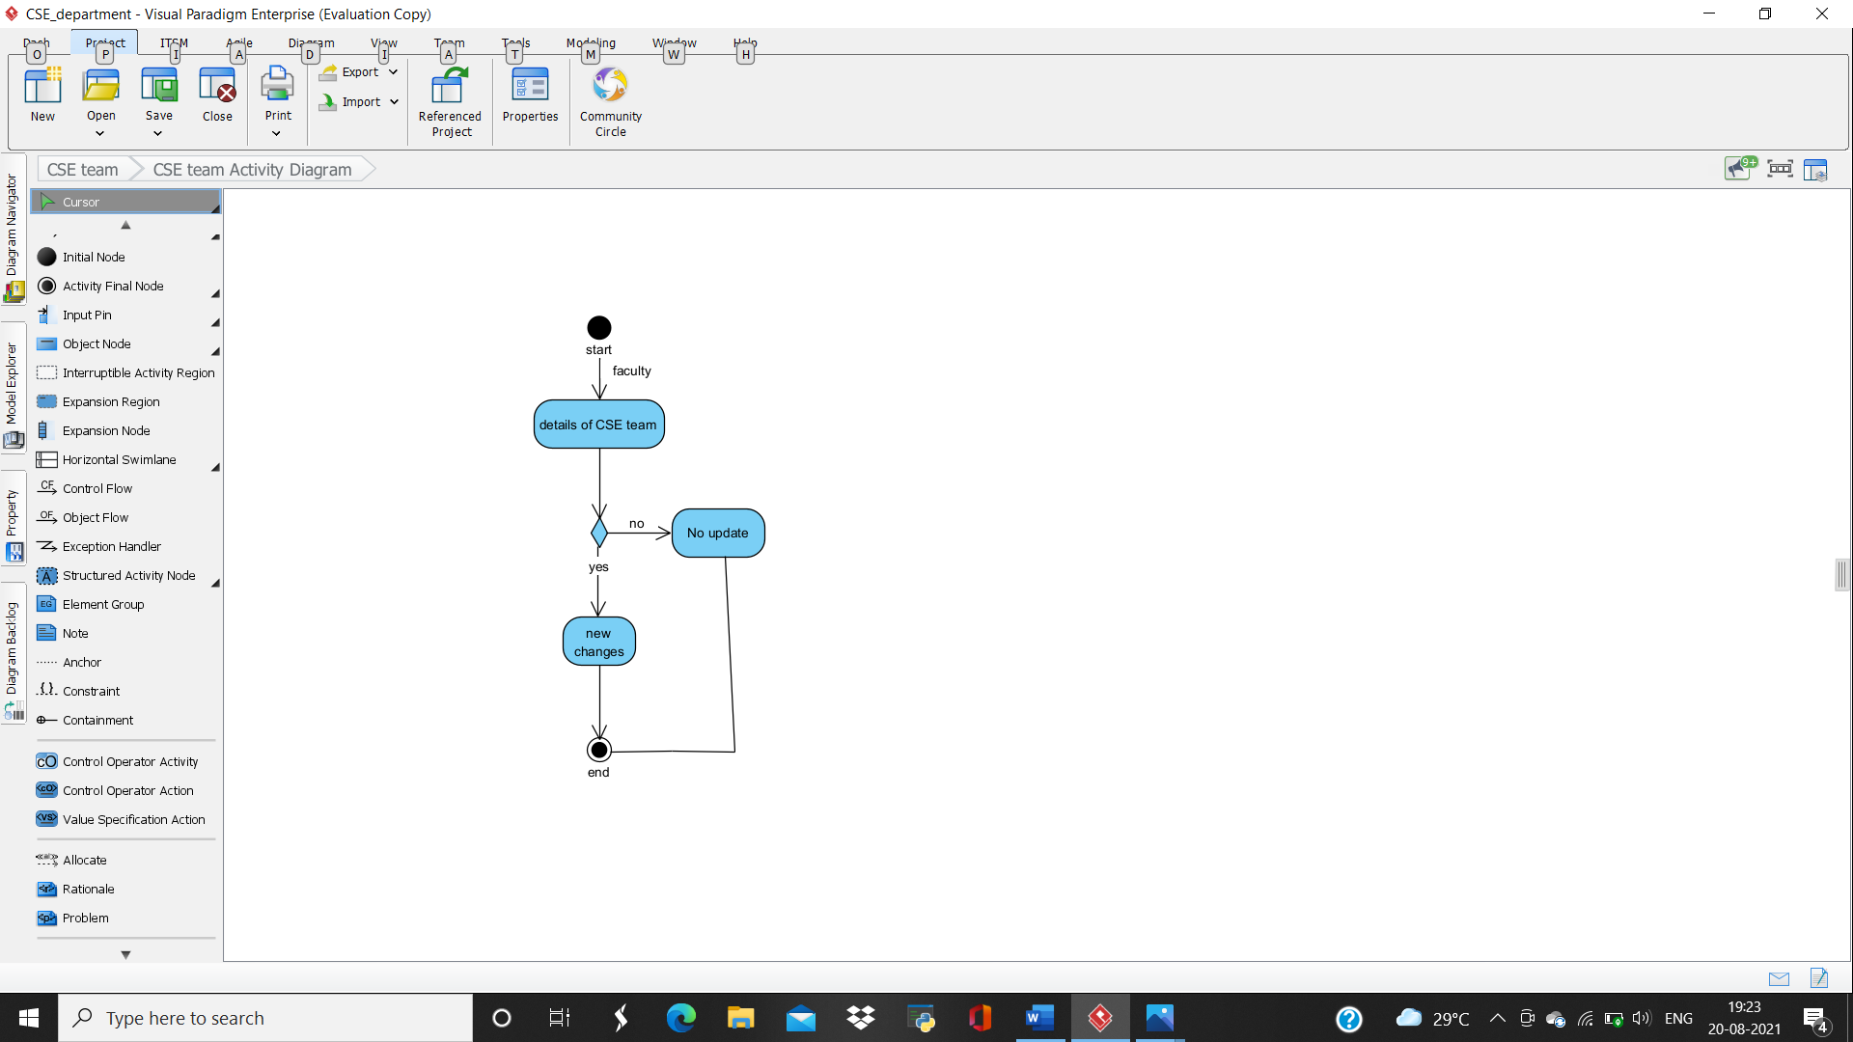

* **ACTIVITY 2**

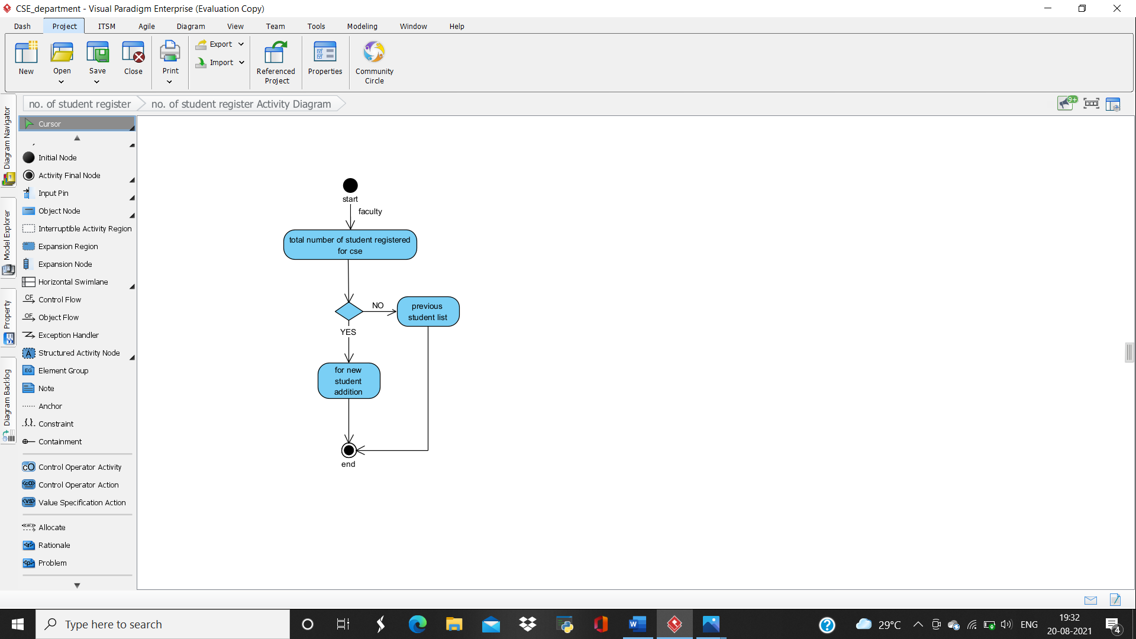

* **ACTIVITY 3**

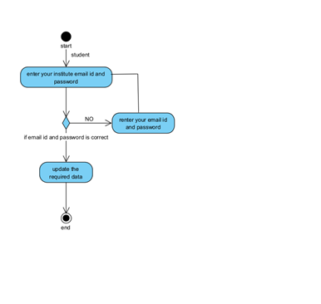

* **ACTIVITY 4**

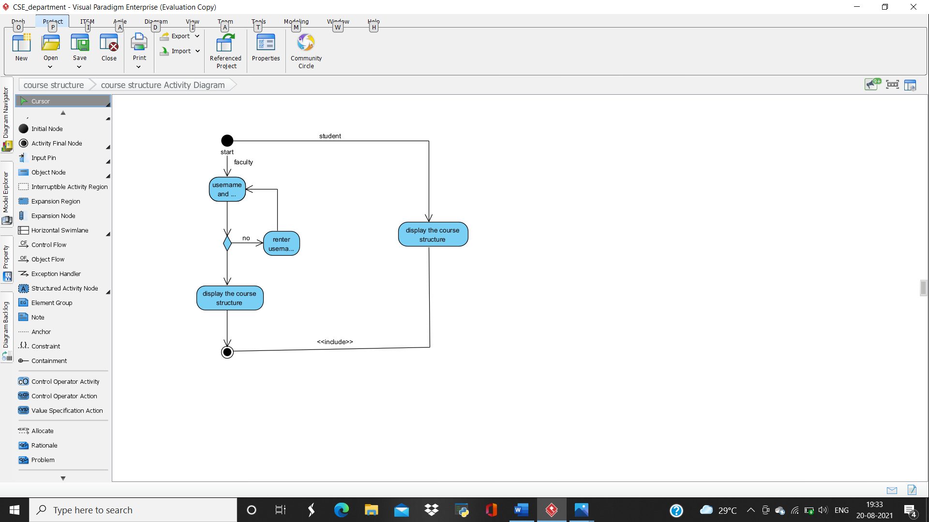

* **ACTIVITY 5**
* 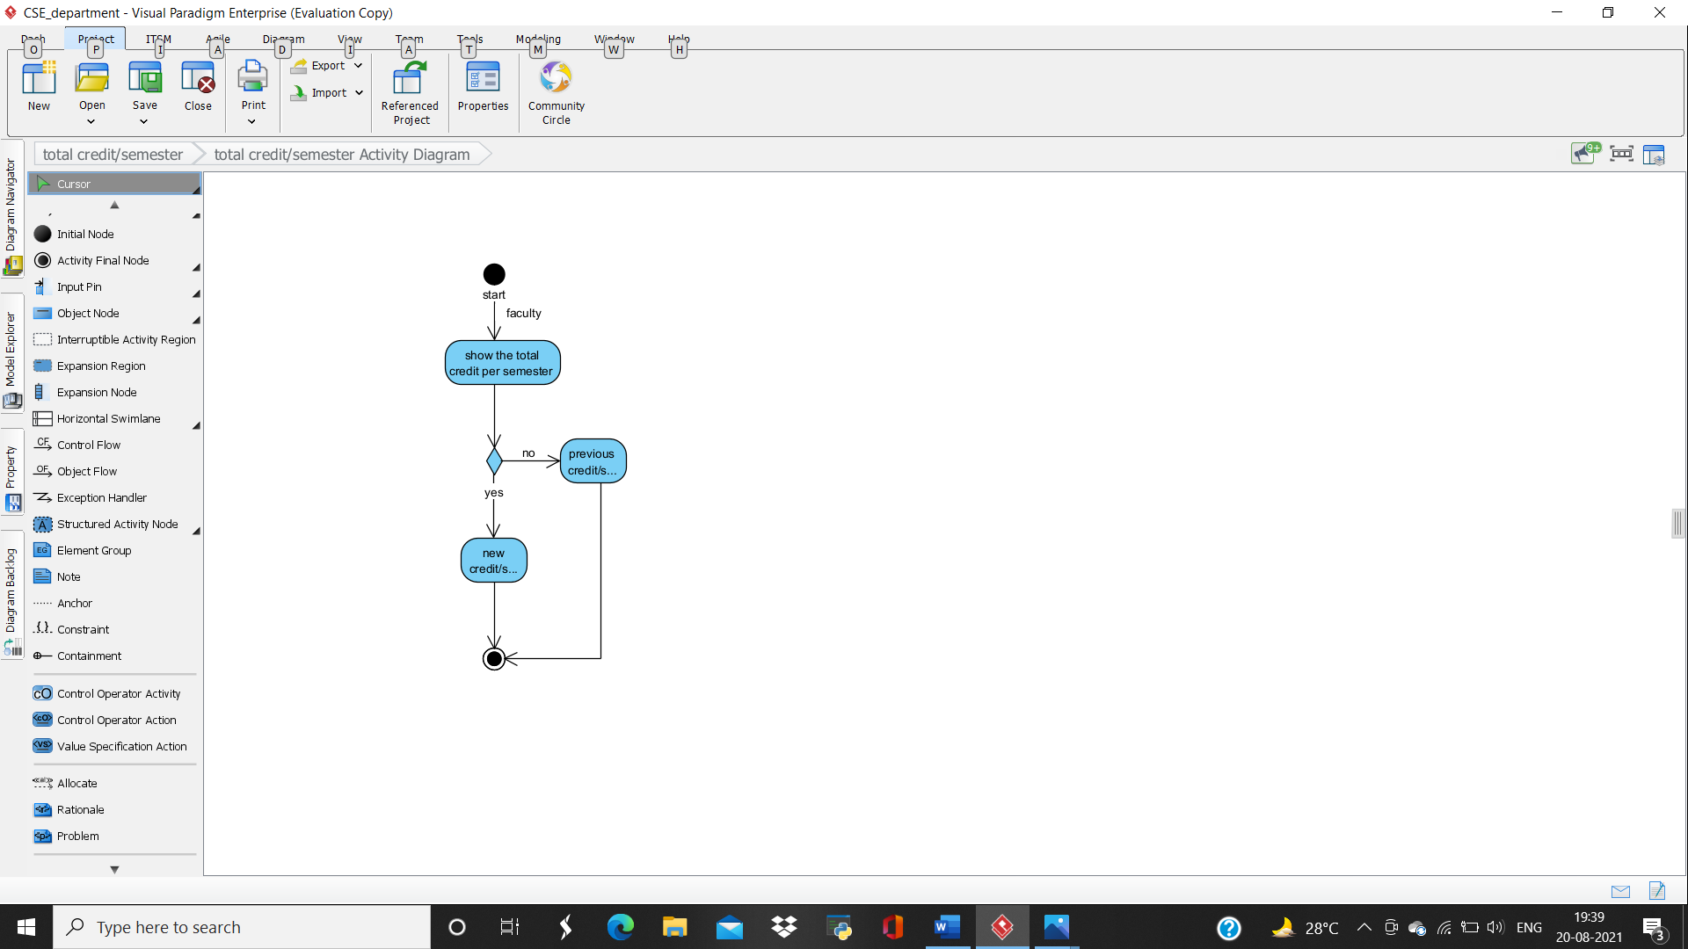
* **ACTIVITY 6**

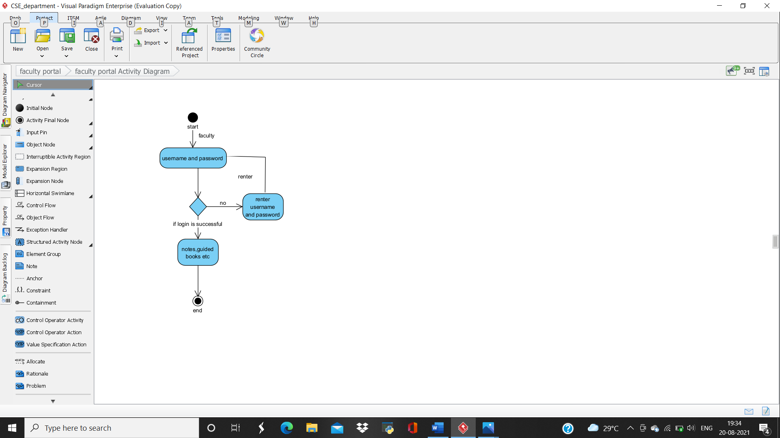

* **ACTIVITY 7**

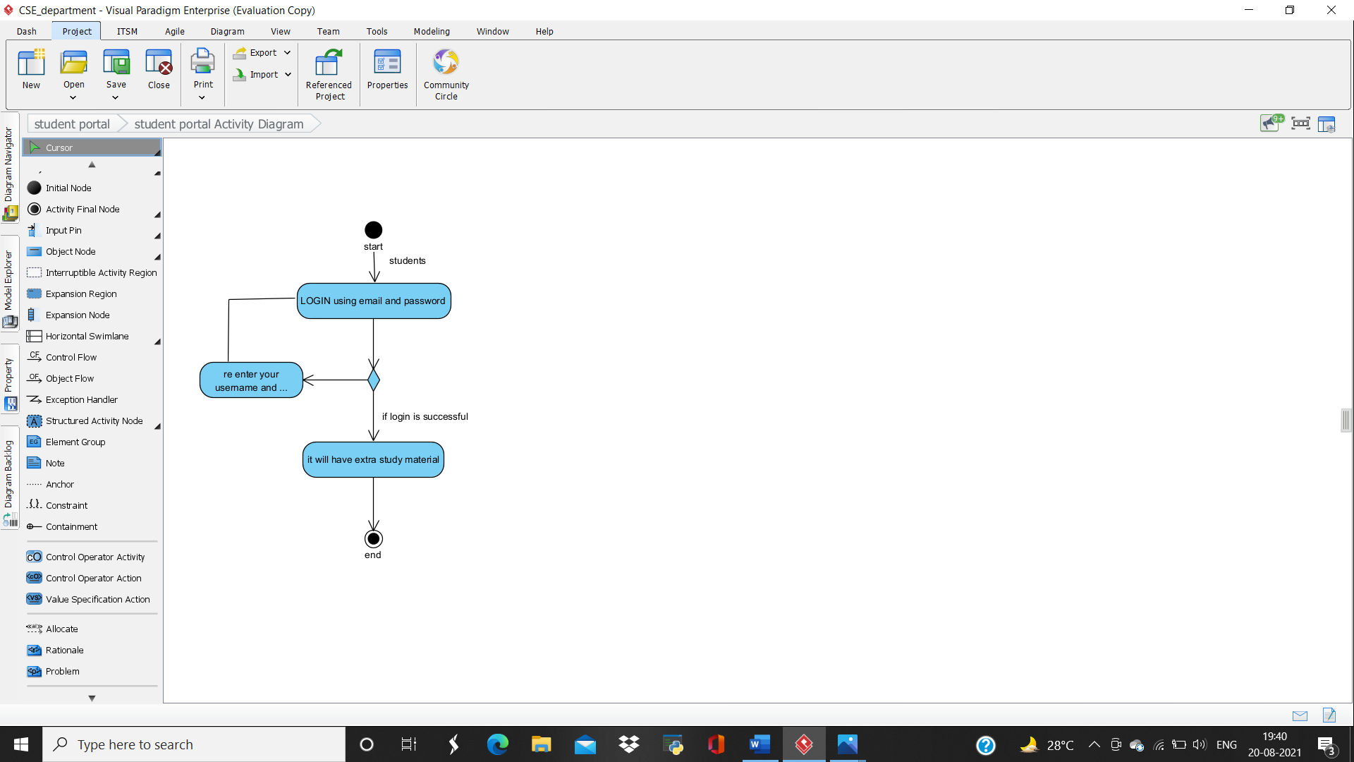

* **ACTIVITY 8**

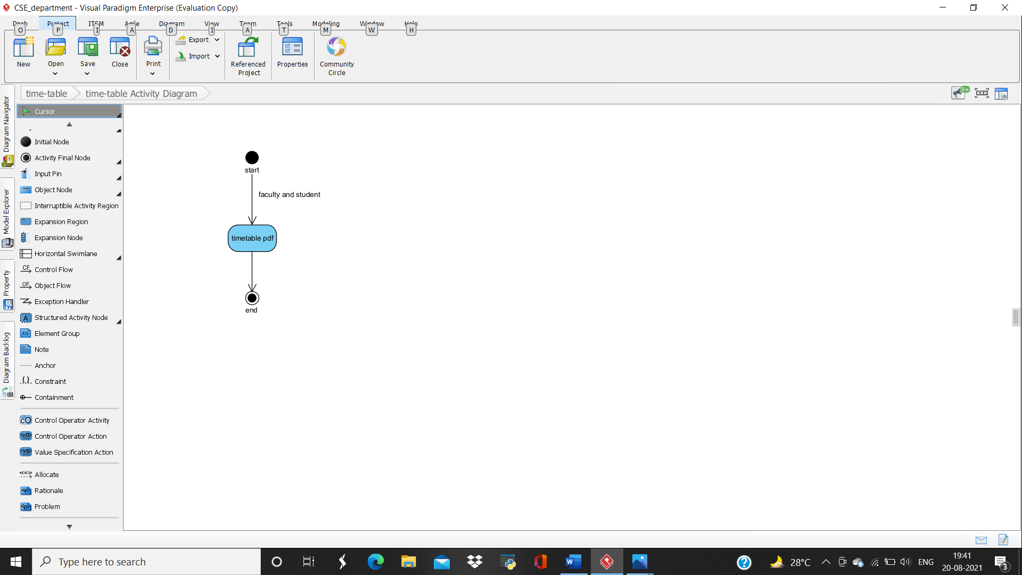

* **ACTIVITY 9**

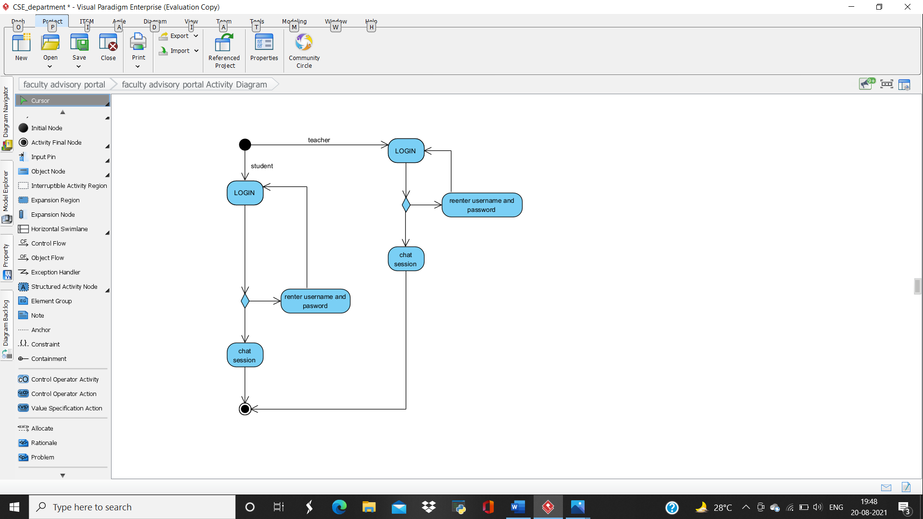

* **ACTIVITY 10**

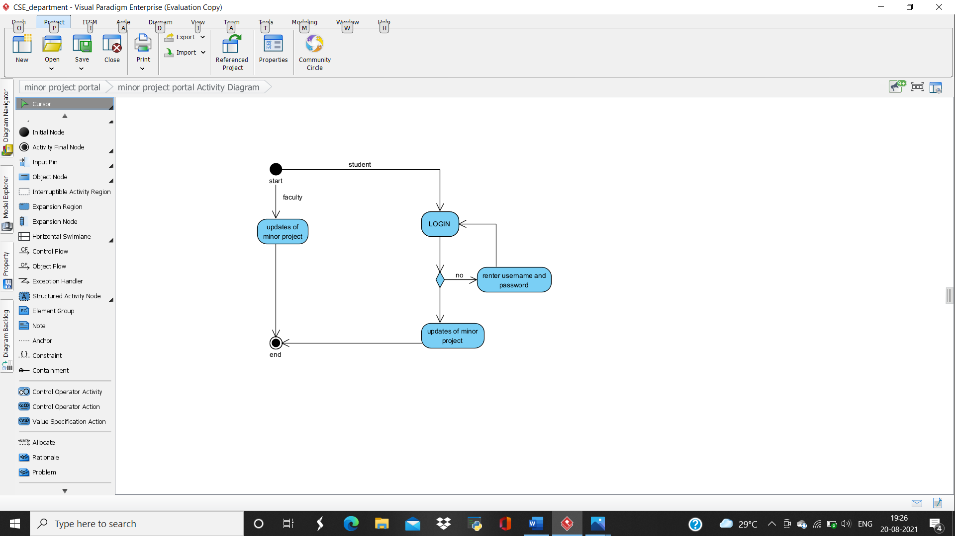

* **ACTIVITY 11**
* 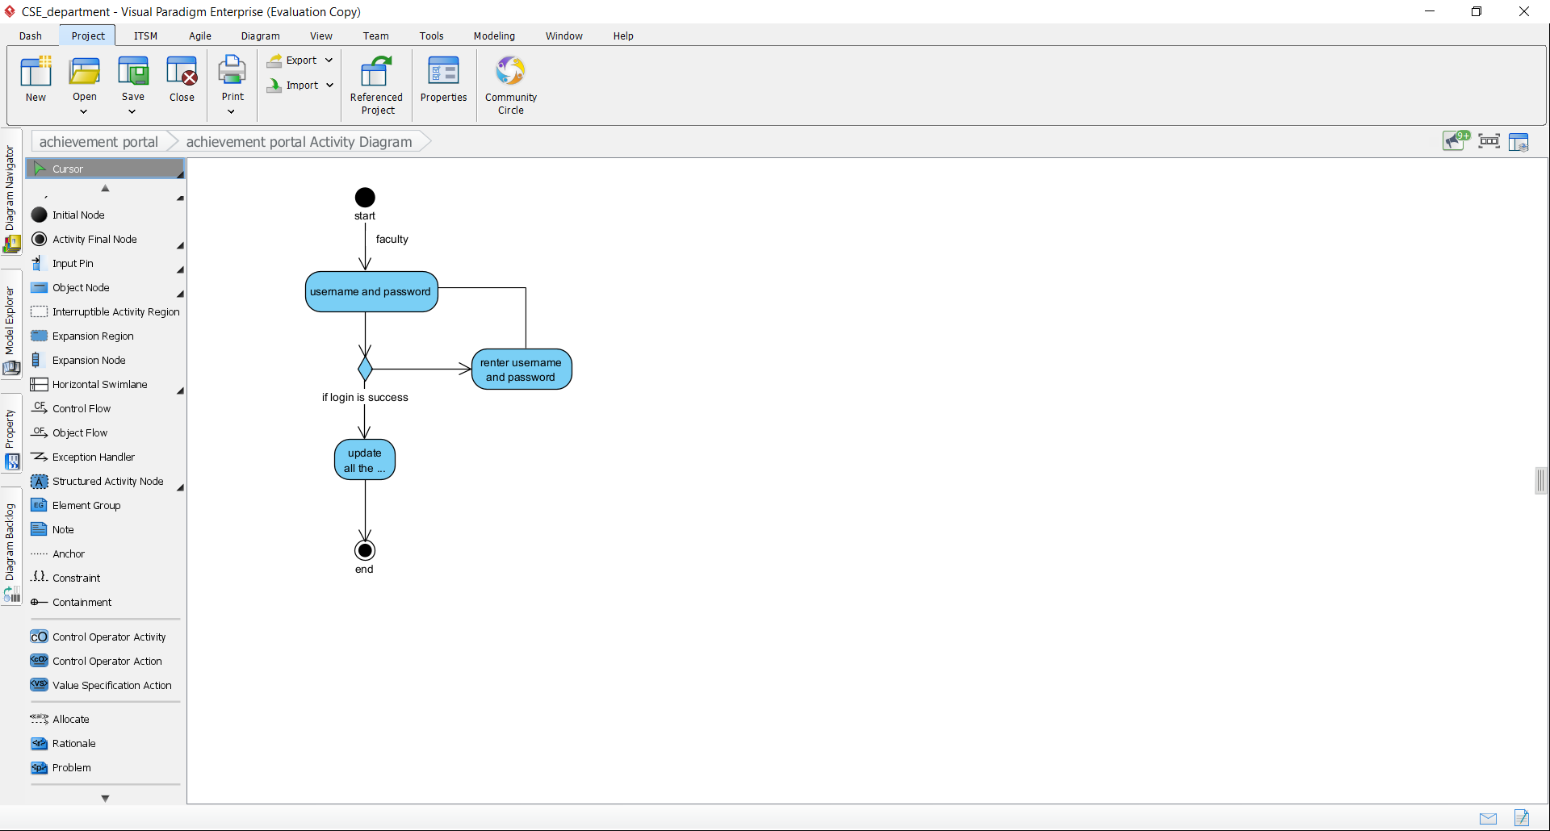
* **ACTIVITY 12**

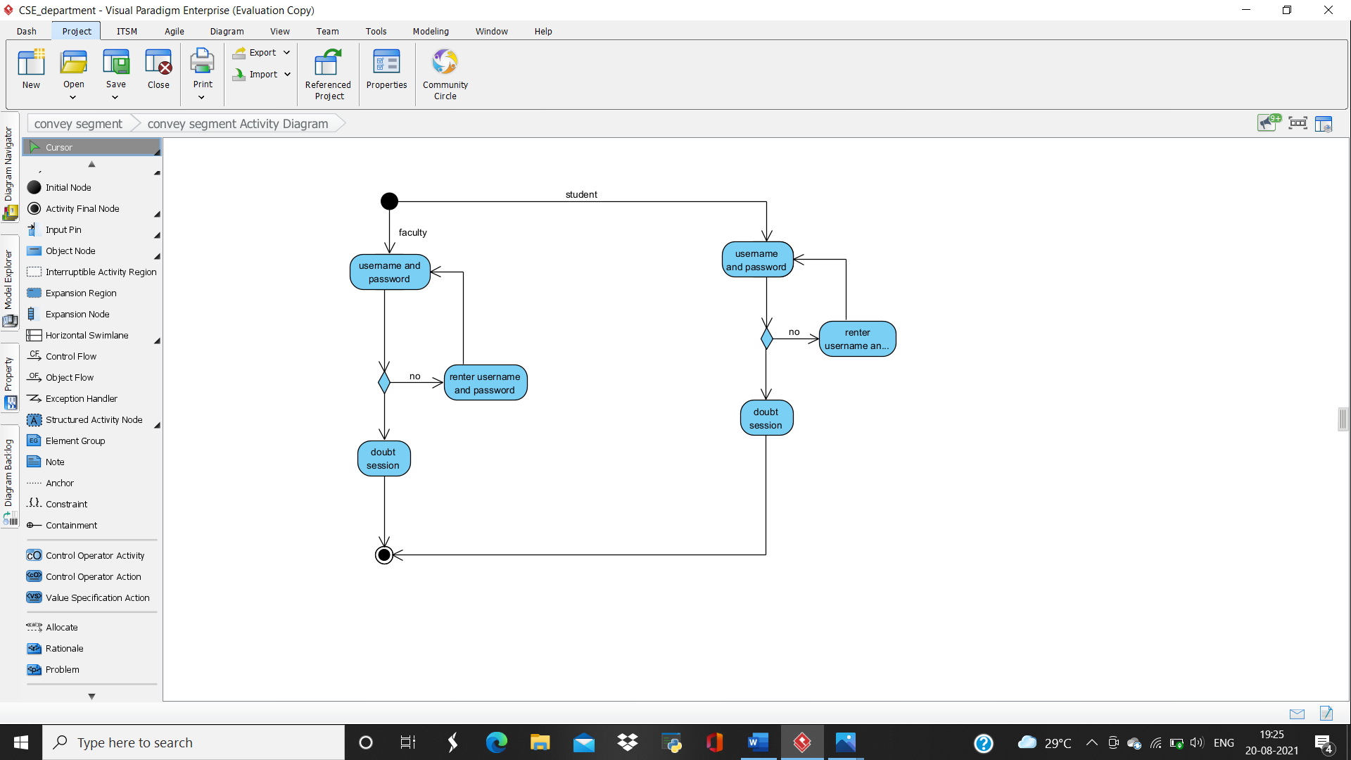

* **ACTIVITY 13**

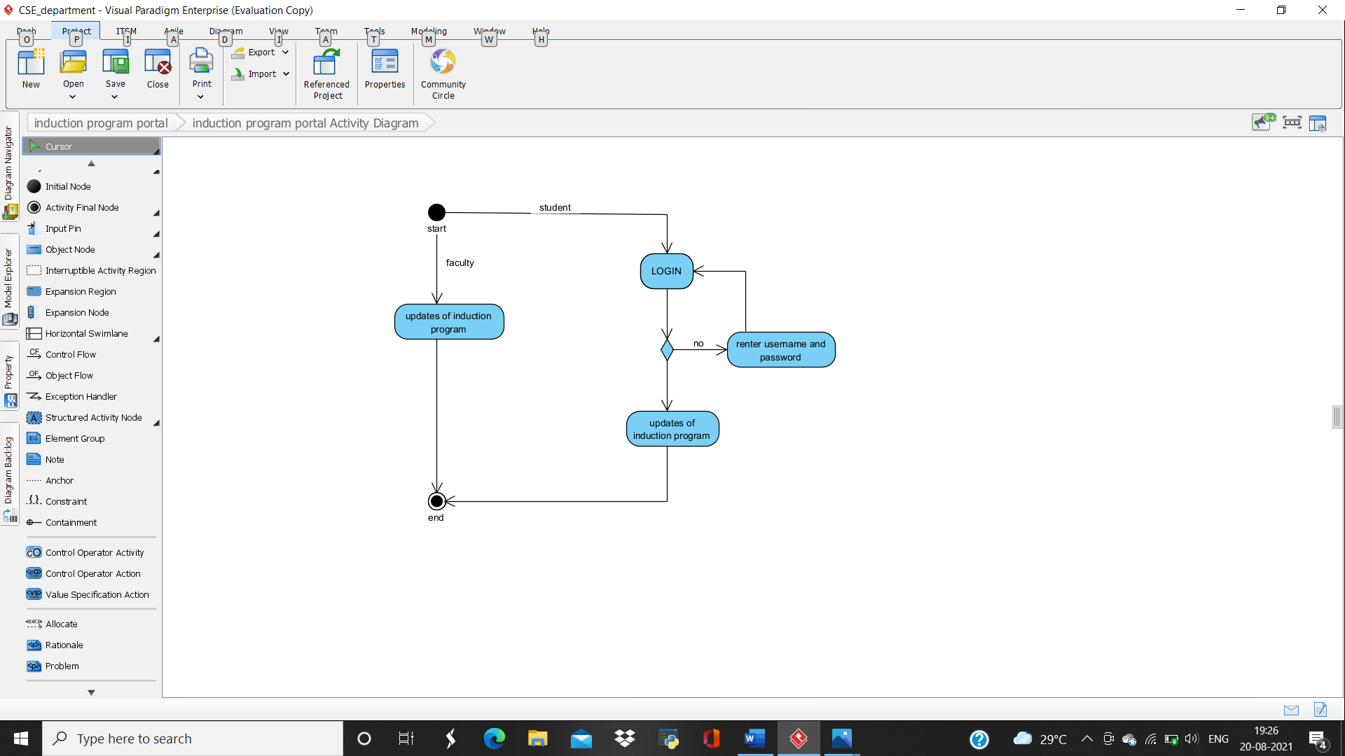

* **ACTIVITY 14**

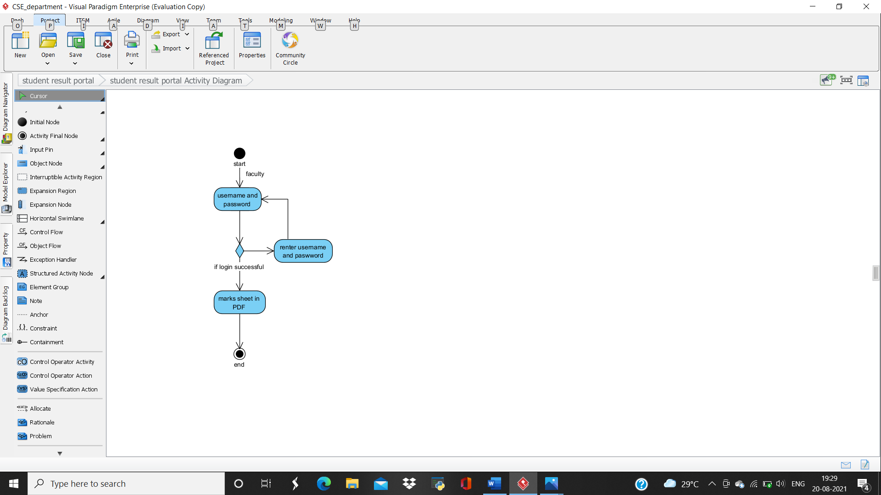

* **ACTIVITY 15**

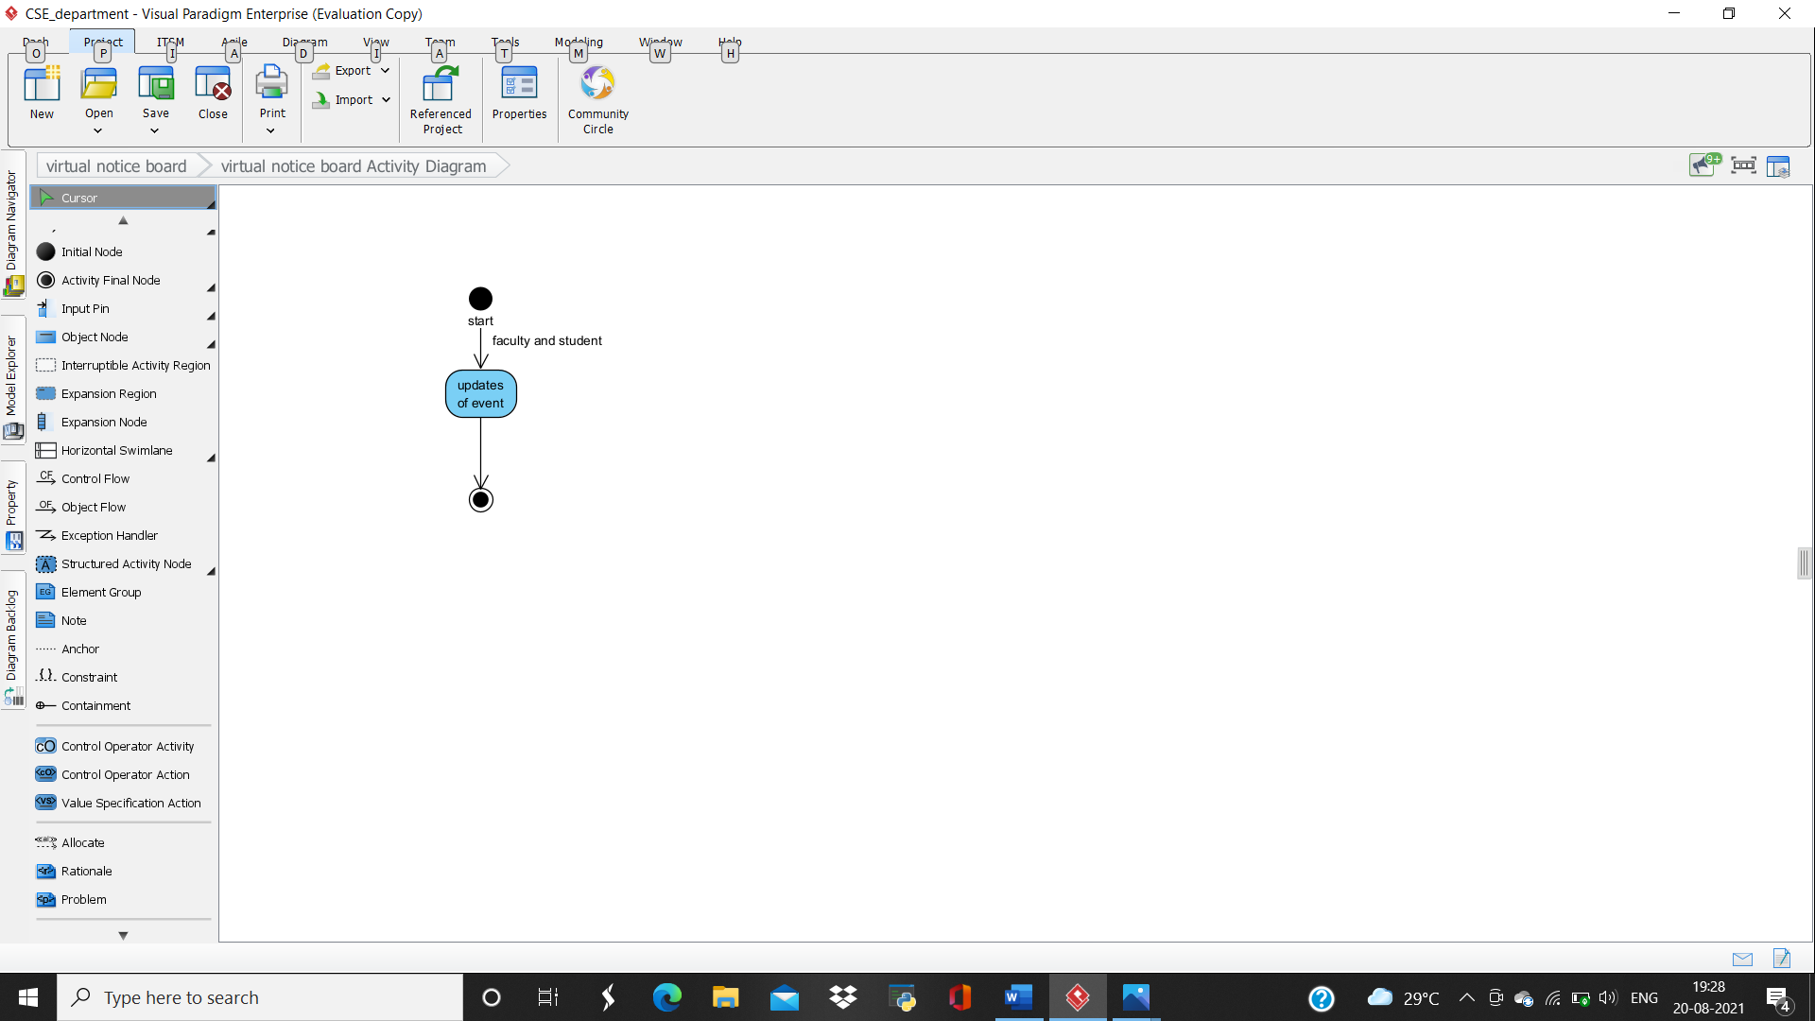

* **ACTIVITY 16**

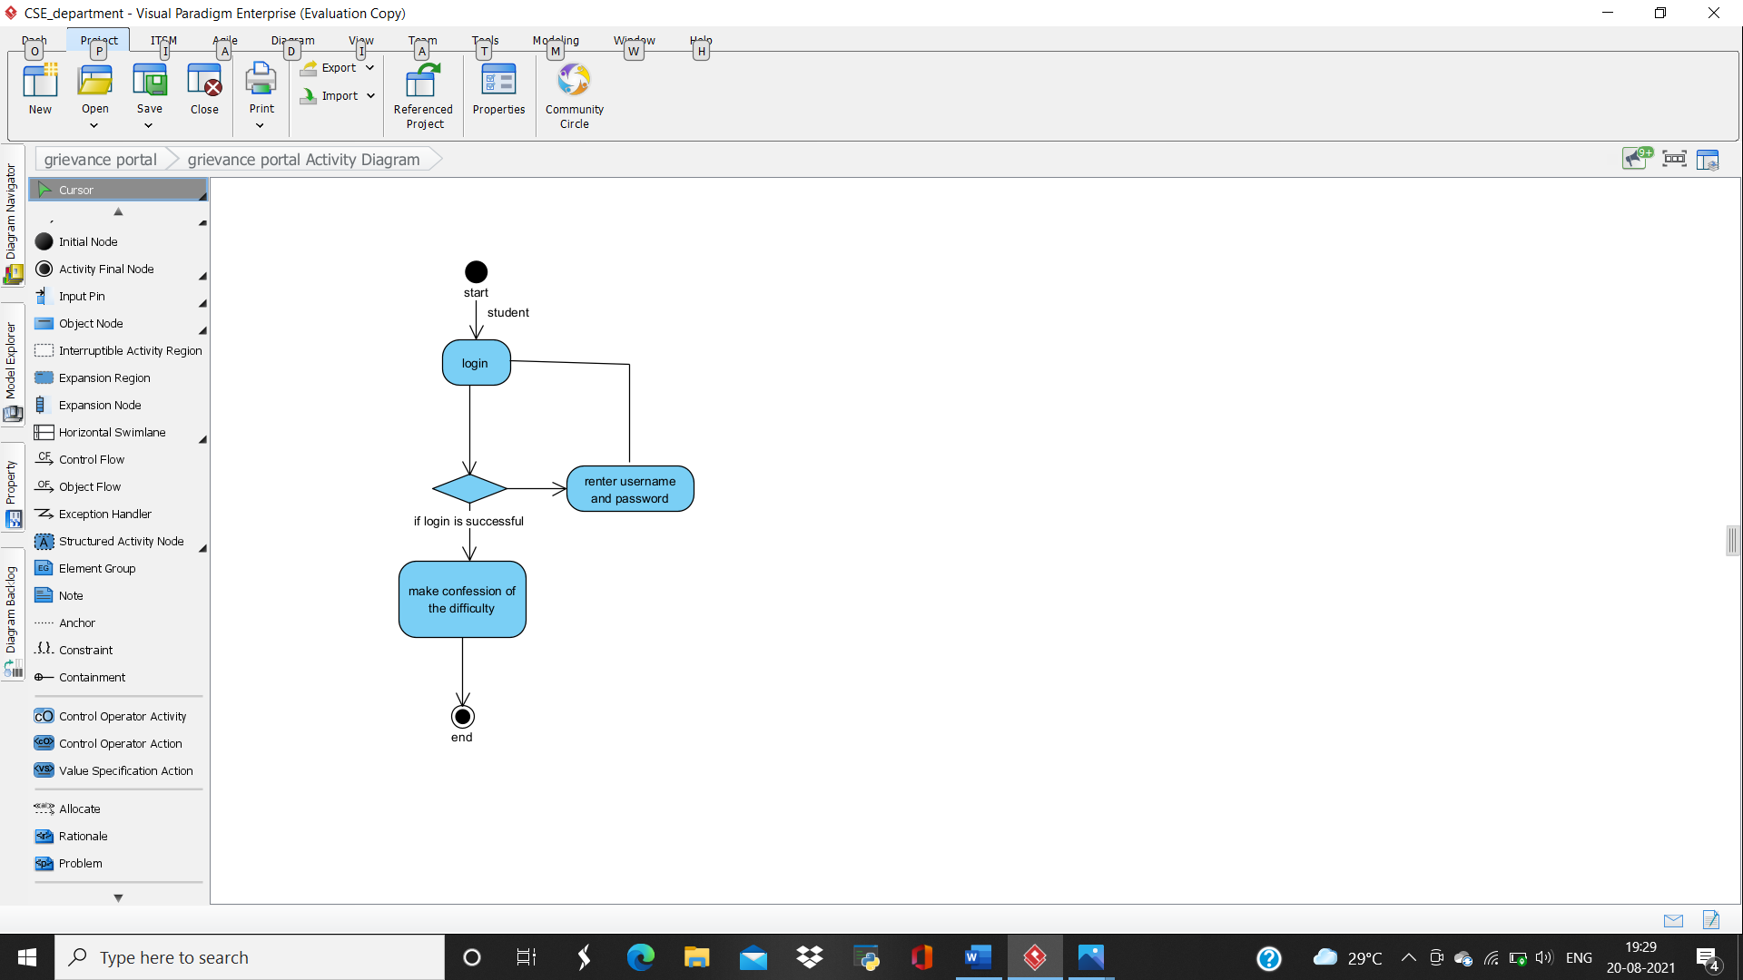

**MODULE 2: CLUB SOCIETY DEPARTMENT**

**#REQUIREMENT**

* **Requirement 1: Faculty advisory detail**
* **Requirement 2: Student committee detail**
* **Requirement 3: Budget planning portal**
* **Requirement 4: Chief guest of the event**
* **Requirement 5: schedule of event**
* **Requirement 6: Invitation card generation**
* **Requirement 7: Certificate generation**
* **Requirement 8: Jury member for competition**
* **Requirement 9: Event notification portal**
* **Requirement 10: Registration of events *more than one event * portal**

**#FUNCTIONAL REQUIREMENT**

* **Requirement 1: Faculty advisory detail**

**Description: This following portal will have the detail of faculty advisory under whom the event is taking place. This portal will be used by admin and only allowed to be visualized by students.**

* **Requirement 2: Student committee detail**

**Description: This following portal will have the details of student committee holding different post regarding the event. This portal will be used by admin only and allow only for visualization to students.**

* **Requirement 3: Budget planning portal**

**Description: This following portal will help student committee to discuss with faculty about the event and the cost estimation for the event. This portal will not be applicable for general purpose.**

* **Requirement 4: Chief guest of the event**

**Description: This following portal will generate a poster having invited the special guest for particular event. This poster will have the brief description of the special guest. This will be used for visualization only.**

* **Requirement 5: schedule of event**

**Description: This following portal will have the list of programs that are going to be held. This will also contain date and time for the particular program. This is used for visualization only.**

* **Requirement 6: Invitation card generation**

**Description: This following portal will have the image of invitation card. This card will have detail of event like date, time, day and chief guest for the day. This will also help in mailing the invitation card to important person of the college.**

* **Requirement 7: Certificate generation**

**Description: This following portal will have the details of all student who will be awarded certificate for the particular event. This is only applicable for event committee only.**

* **Requirement 8: Jury member for competition**

**Description: This following portal will have the detail of jury members who will be judging for the particular program. According to their marks, awards will be given away. For admin use only.**

* **Requirement 9: Event notification portal**

**Description: This following portal will give all the notification of event coming by. It will also have an idea of what type event is it and it will also help in encouragement in participation of event. This portal is applicable for students only.**

* **Requirement 10: Registration of events *more than one event * portal**

**Description: This following will help student to register themselves for the types of event/competition to be held. This will also have detail of competition. Here, students have to fill their details like name, roll no., branch, year.**

**#USE CASE DIAGRAM**

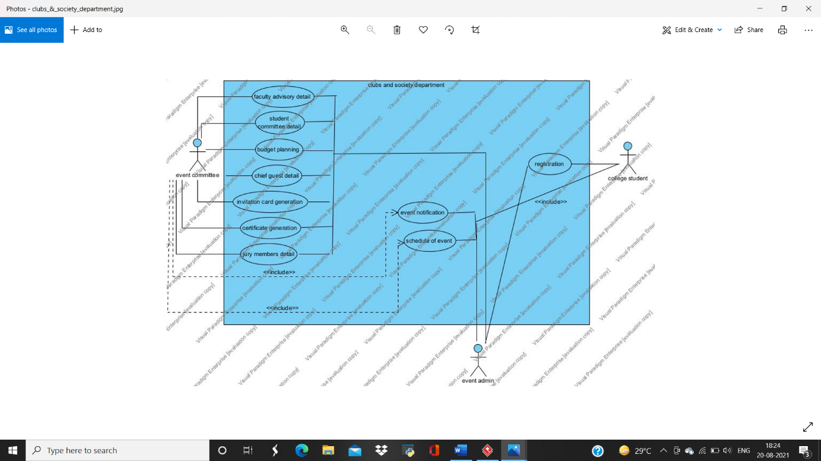

**#ACTIVITY DIAGRAM**

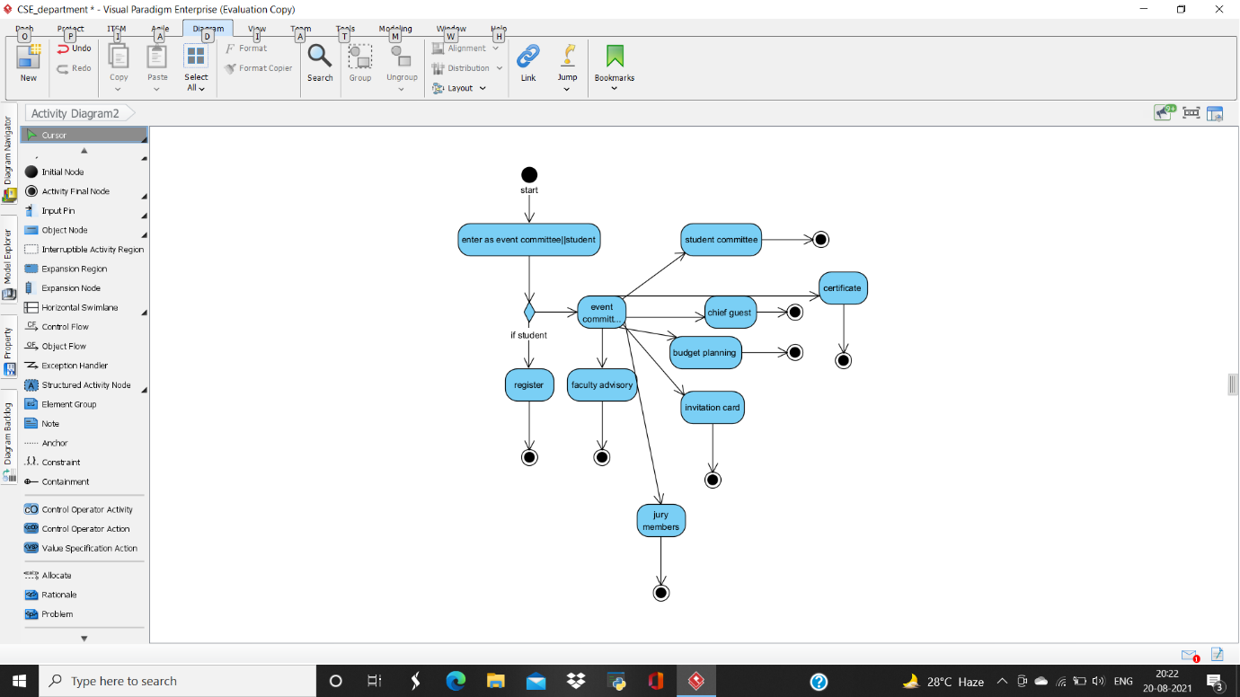

**• ACTIVITY 1**

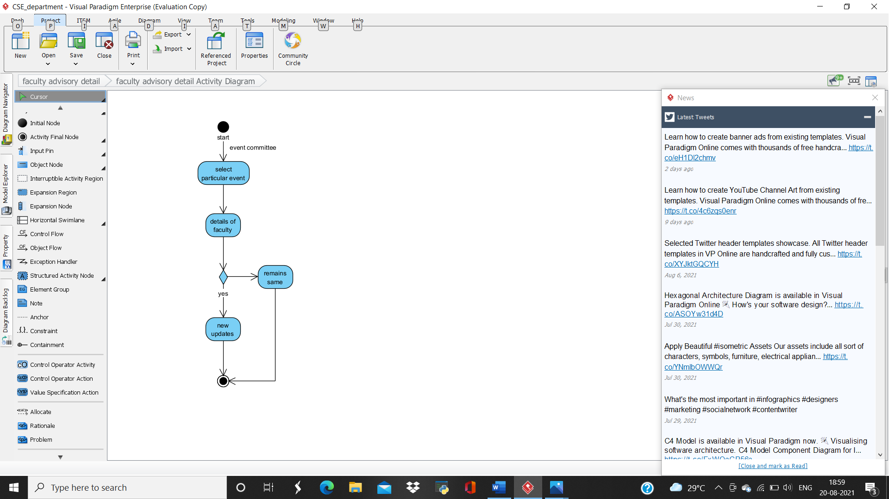

**• ACTIVITY 2**

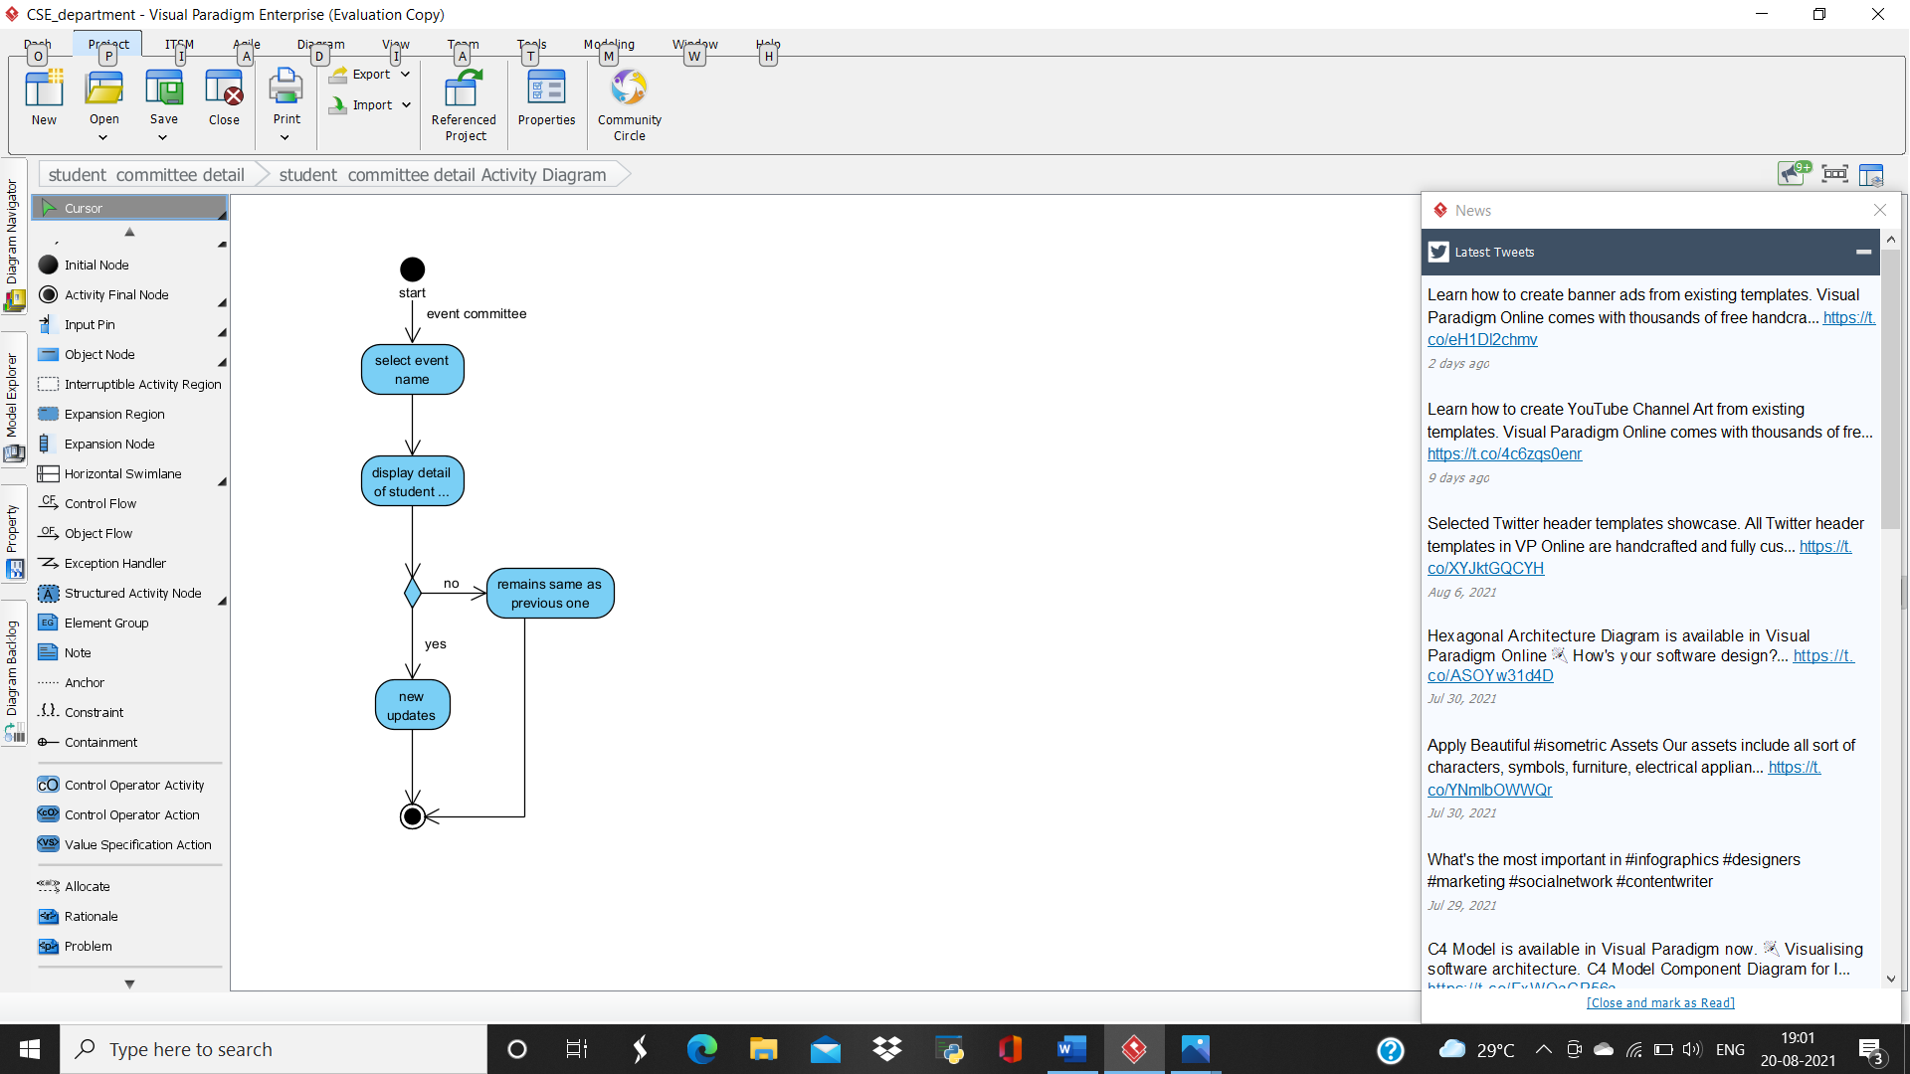

**• ACTIVITY 3**

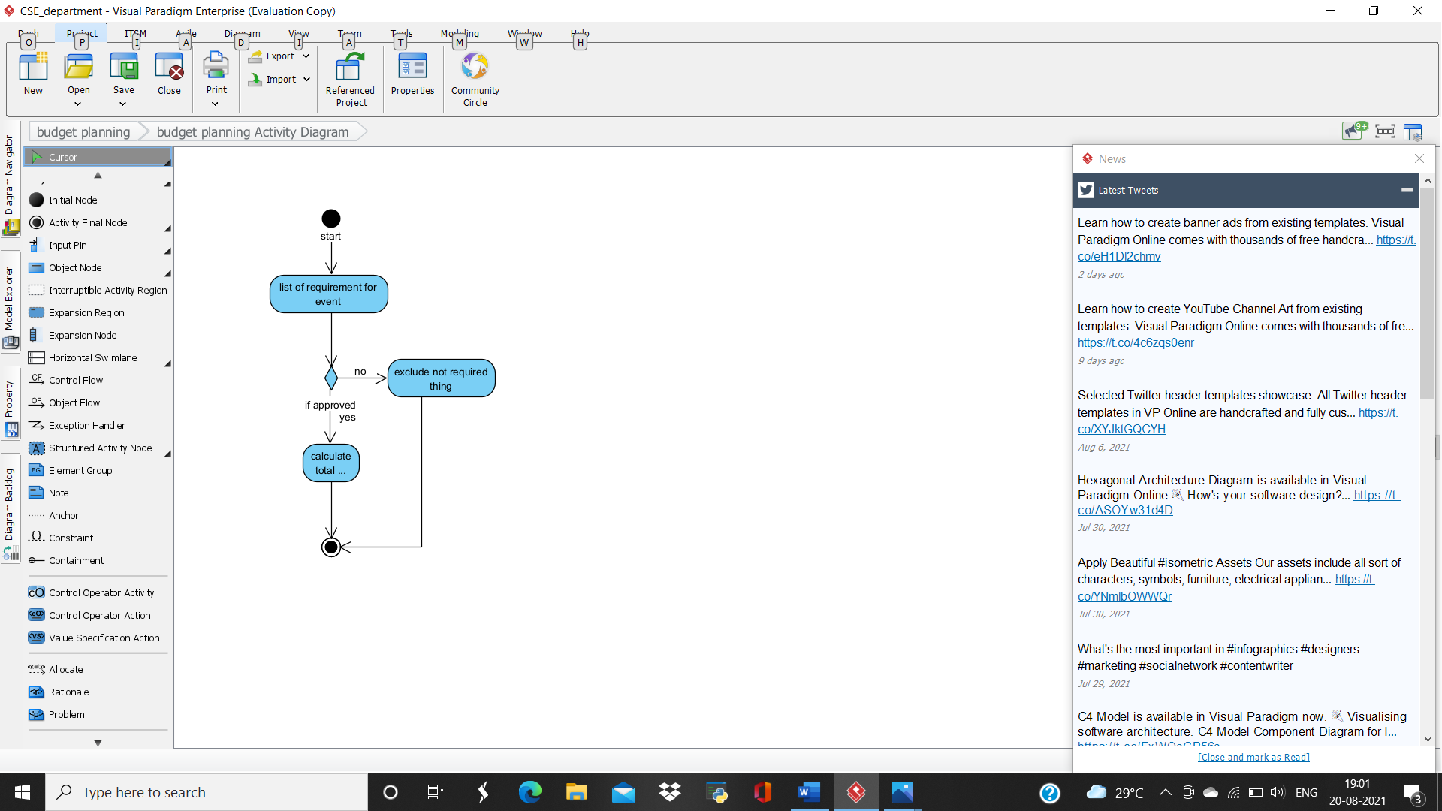

**• ACTIVITY 4**

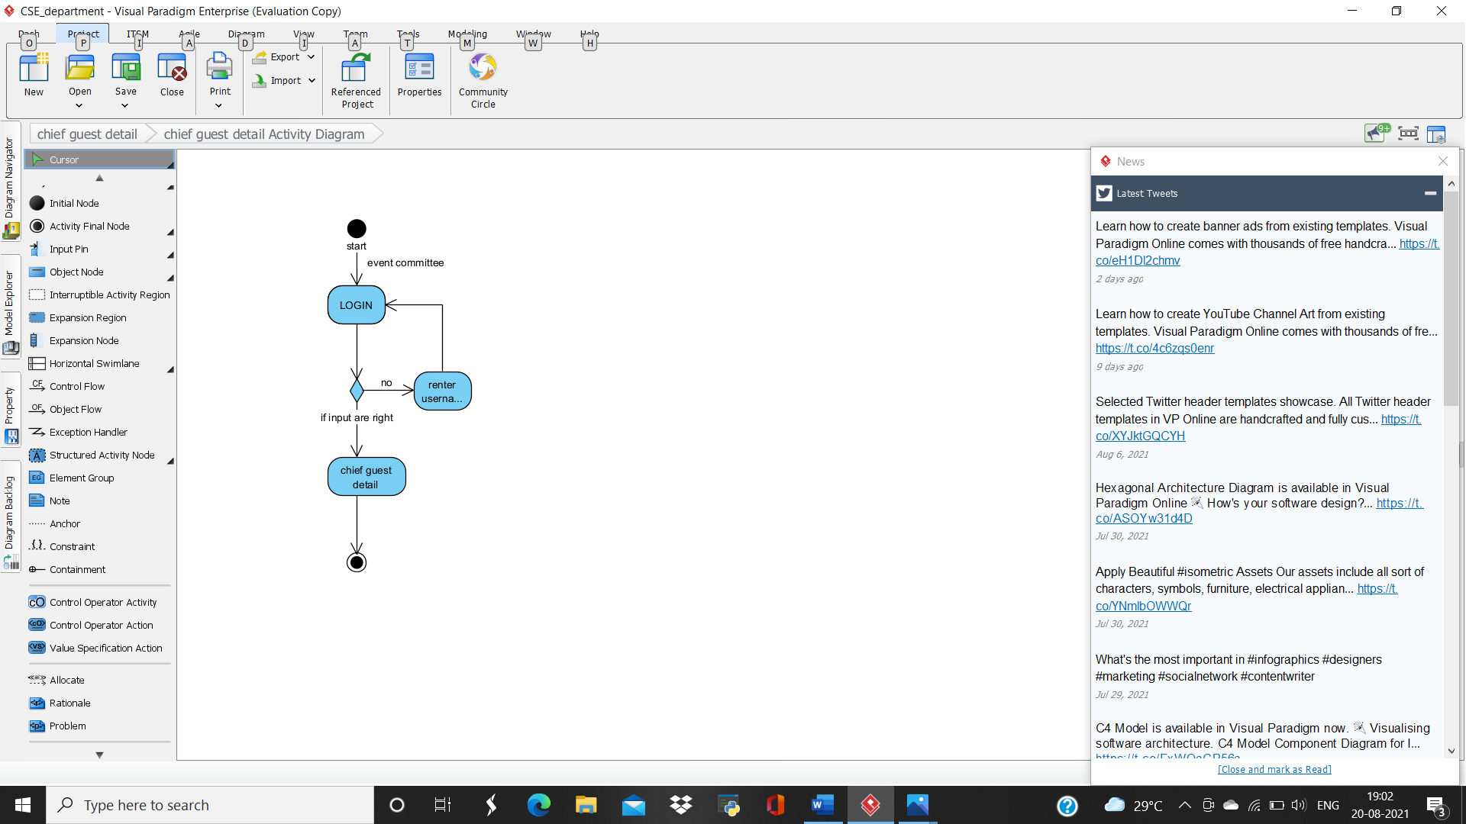

**• ACTIVITY 5**

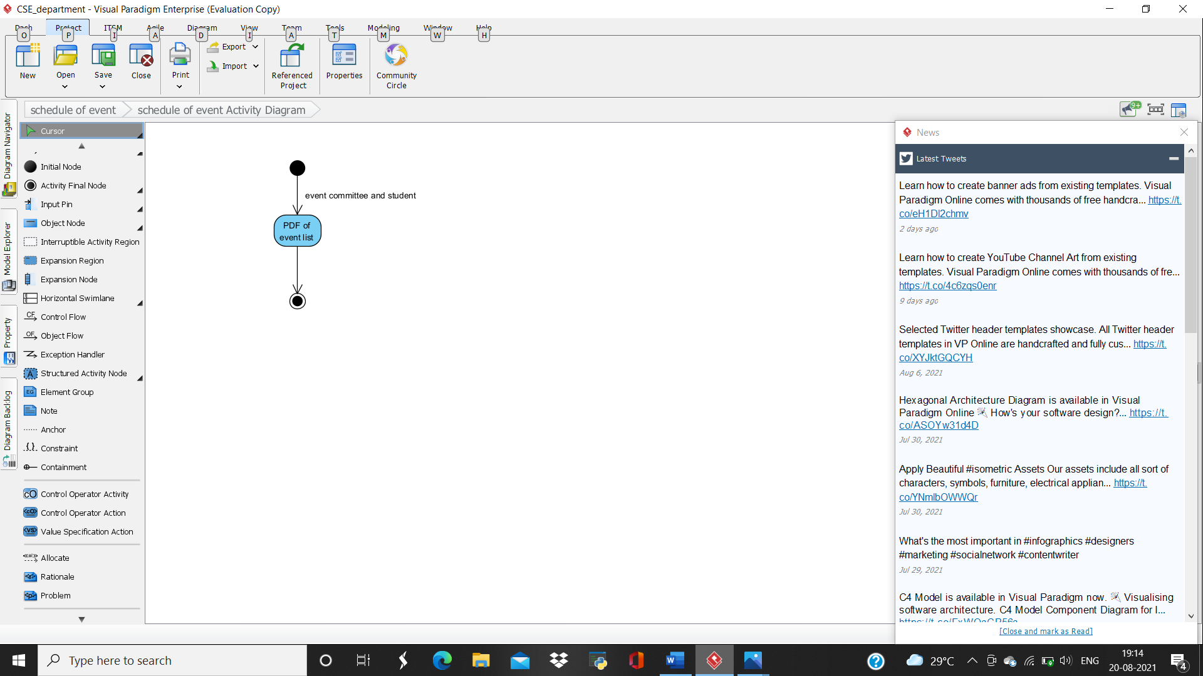

**• ACTIVITY 6**

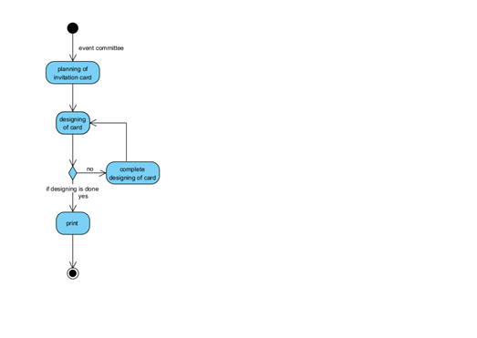

**• ACTIVITY 7**

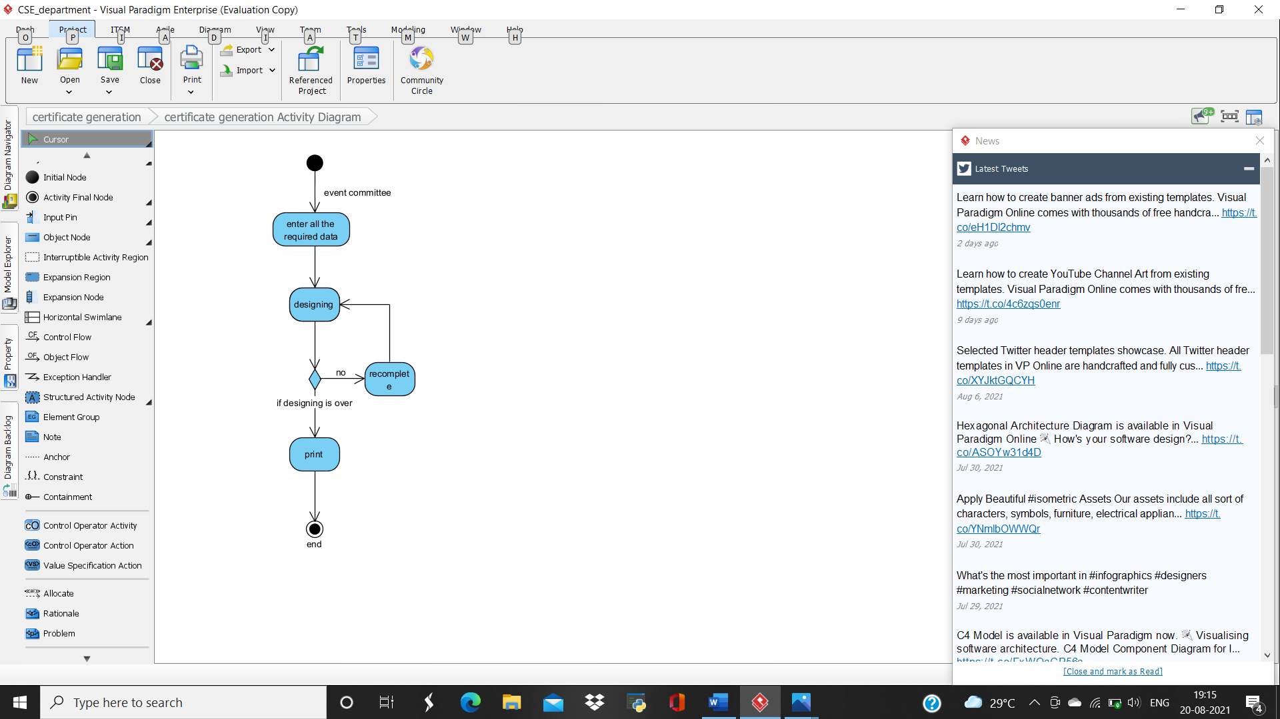

**• ACTIVITY 8**

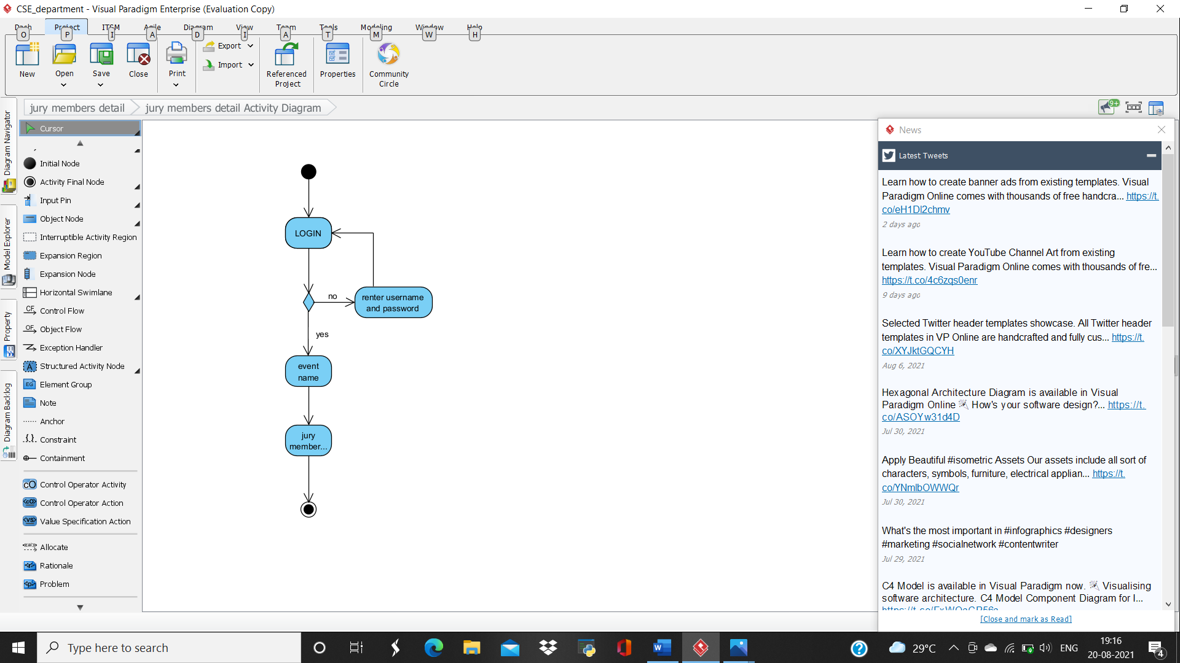

**• ACTIVITY 9**

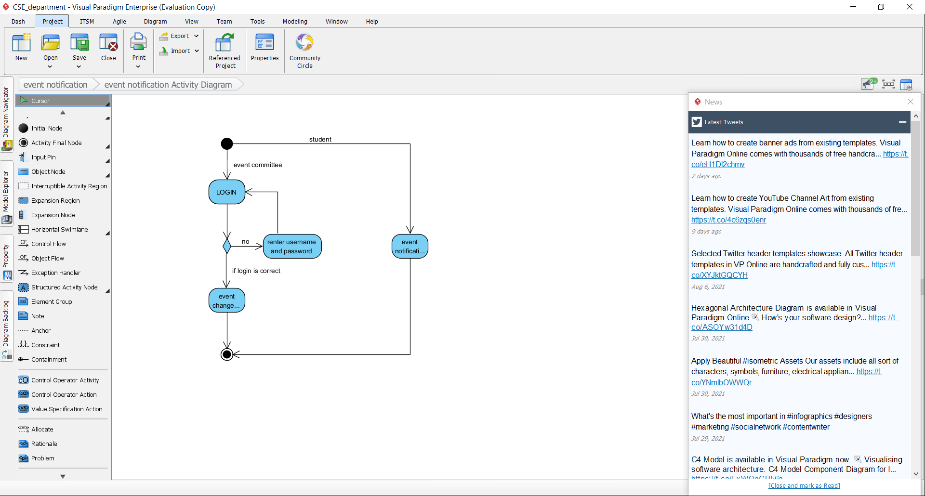

**• ACTIVITY 10**

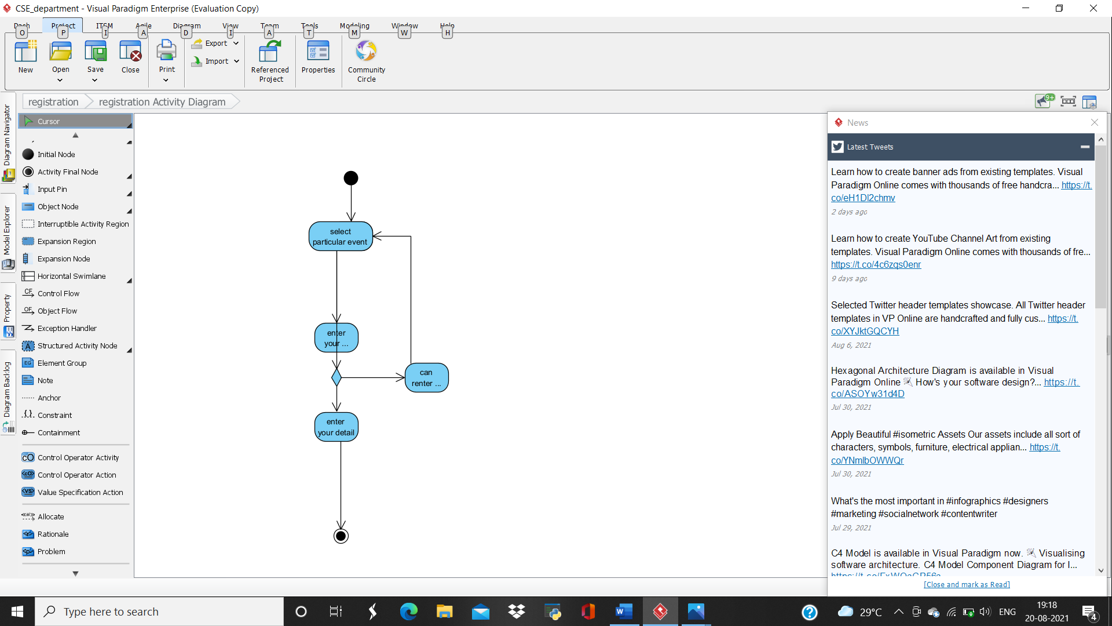

**MODULE 3: GIRL’ S HOSTEL DEPARTMENT**

**#REQUIREMENT**

* **Requirement 1: Hostel superintendent detail**
* **Requirement 2: Hostel staff detail**
* **Requirement 3: Mess attendance portal**
* **Requirement 4: Room detail portal**
* **Requirement 5: washroom portal**
* **Requirement 6: Electricity and electric equipment provision**
* **Requirement 7: WIFI provision**
* **Requirement 8: General hostel equipment portal**
* **Requirement 9: Mess committee detail**
* **Requirement 10:** **Semester mess schedule and Monthly mess bill generation**
* **Requirement 11: E-pass for vacation/emergency**
* **Requirement 12: Additional activity of hostel portal**
* **Requirement 13: General complain box**
* **Requirement 14: Mess complain box**

**#FUNCTIONAL REQUIREMENT**

* **Requirement 1: Hostel superintendent detail**

**Description: this following portal will have details of our hostel. It will contain her name, phone number and email ID. This portal will be used by admin and teachers only.**

* **Requirement 2: Hostel staff detail**

**Description: This following portal will have details of the hostel caretakers with their specific name, address, and phone number. This is for admin only.**

* **Requirement 3: Mess attendance portal**

**Description: This following portal will have the regular attendance of the students who are consuming meal per day. This will be helpful in calculating monthly mess bill.**

* **Requirement 4: Room detail portal**

**Description: This following portal will have the details of room like total number of rooms available, number of rooms functioning and also all the equipment provided to students like bed, chair, table and shelf to store their belongings.**

* **Requirement 5: washroom portal**

**Description: This following portal will have all the details of the hostel washroom like total number of washrooms, number of washroom functioning, number of wash basin, tapes, geysers.**

* **Requirement 6: Electricity and electric equipment provision**

**Description: This following portal will have all the details of electric equipment provided to students. Also, it will have details of all electric equipment in common area such as courtyard, street-light.**

* **Requirement 7: WIFI provision**

**Description: This following portal will have direct accessing to WIFI for all the student. Where they can enter their bandwidth and access it for further use.**

* **Requirement 8: General hostel equipment portal**

**Description: This following portal will have details number of fire extinguisher in each floor, emergency medical help to student.**

* **Requirement 9: Mess committee detail**

**Description: This following portal will have details of students who are the post bearer of mess committee. It will consist of name, roll number, batch, phone number and email ID.**

* **Requirement 10: Semester mess schedule and Monthly mess bill generation**

**Description: This following portal will have the weekly mess chat. This portal will also be reliable in calculation of mess bill per student.**

* **Requirement 11: E-pass for vacation/emergency**

**Description: This following portal will provide student to apply online for the gate pass if student want holiday.**

* **Requirement 12: Additional activity of hostel portal**

**Description: This portal will have all the details of the recreation room and its equipment, gym and its equipment.**

* **Requirement 13: General complain box**

**Description: This following portal will have allowance to the student where they can share their grievance against hostel.**

* **Requirement 14: Mess complain box**

**Description: This following portal will have allowance to the students where they can share problems facing by them regarding hostel mess.**

**#USE CASE DIAGRAM**

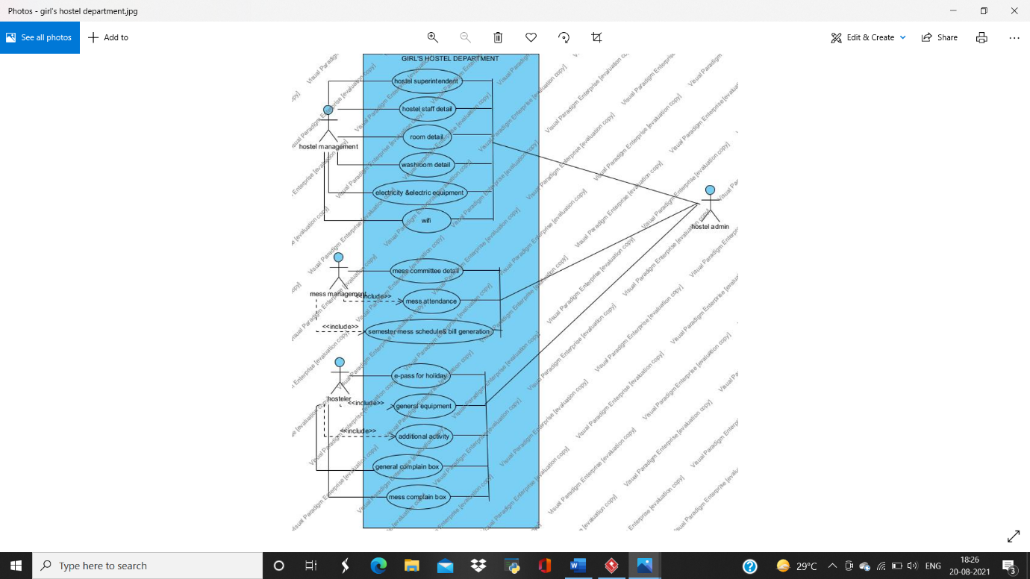

**#ACTIVITY DIAGRAM**

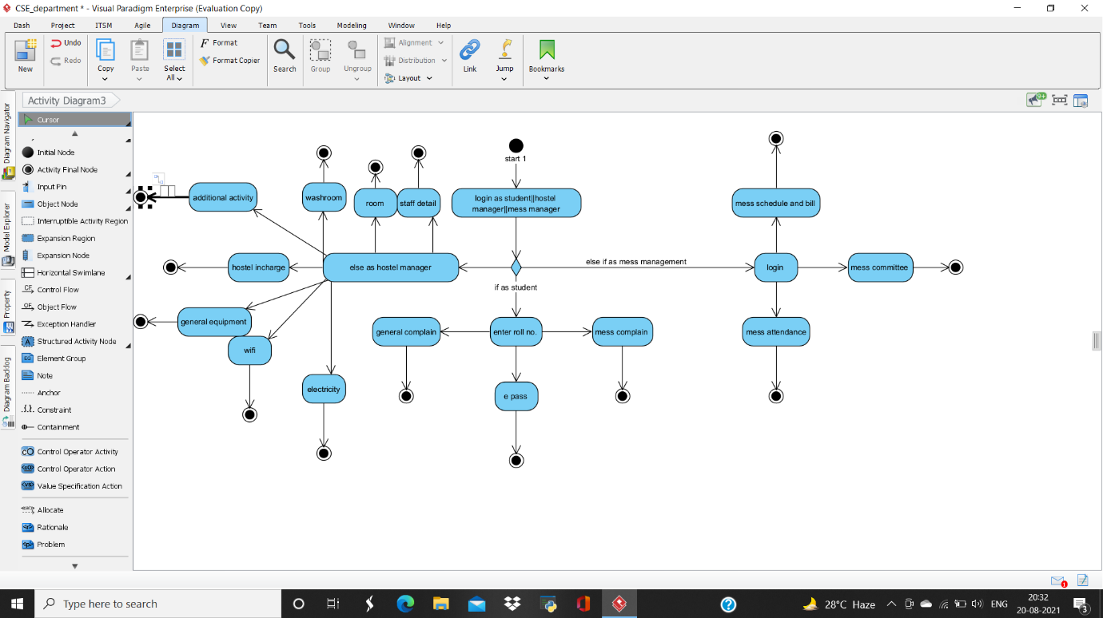

**• ACTIVITY 1**

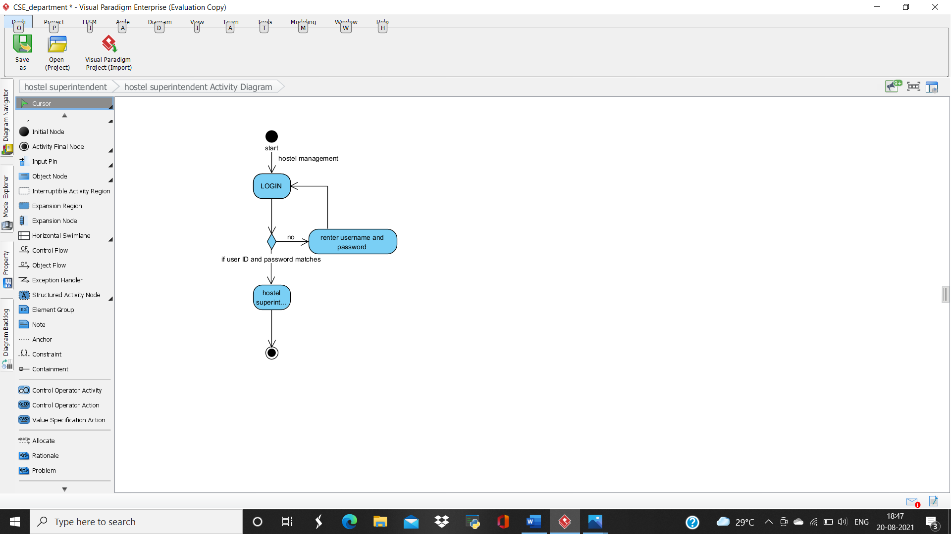

**• ACTIVITY 2**

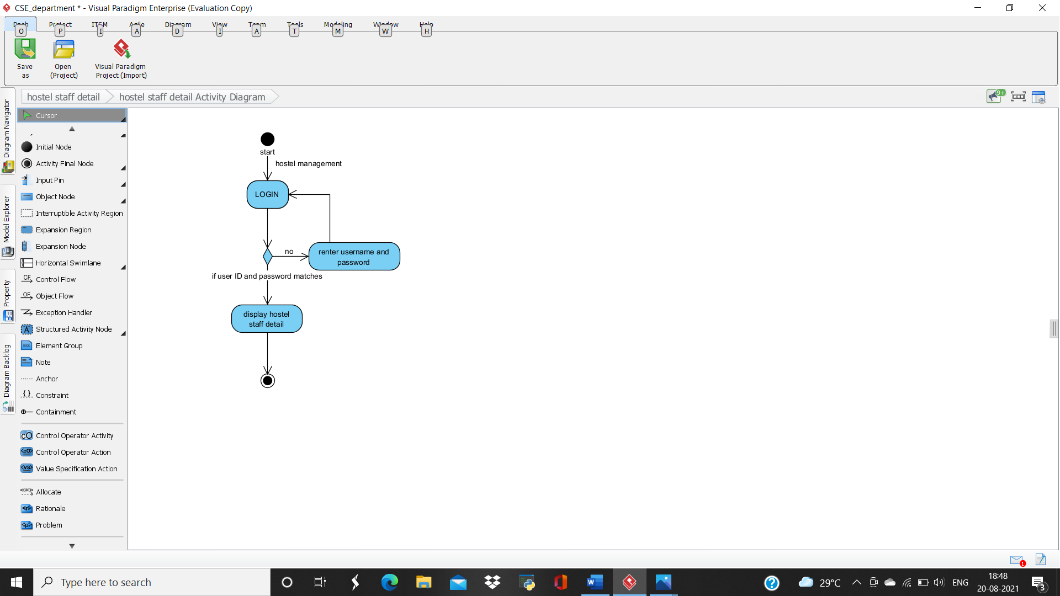

**• ACTIVITY 3**

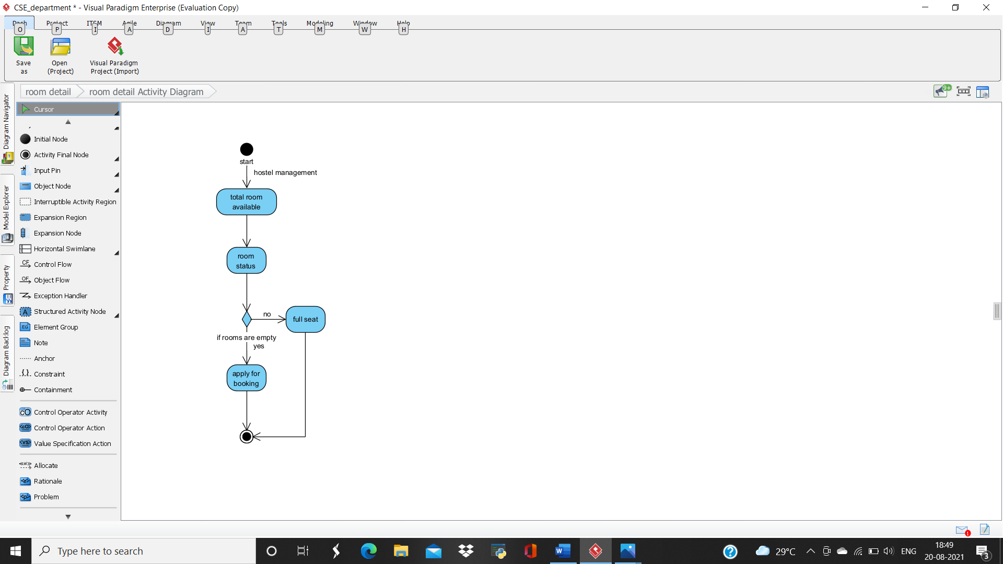

**• ACTIVITY 4**

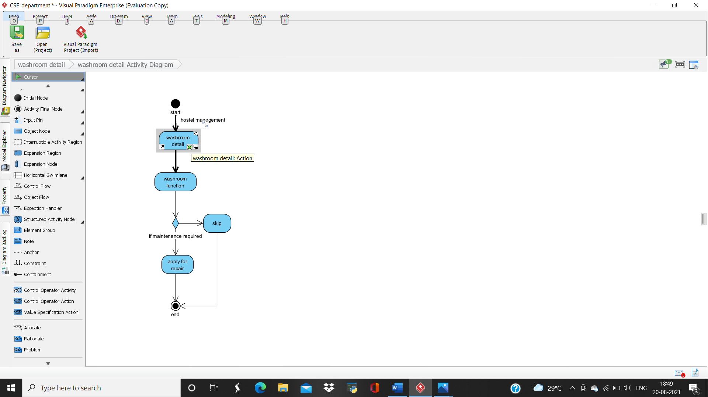

**• ACTIVITY 5**

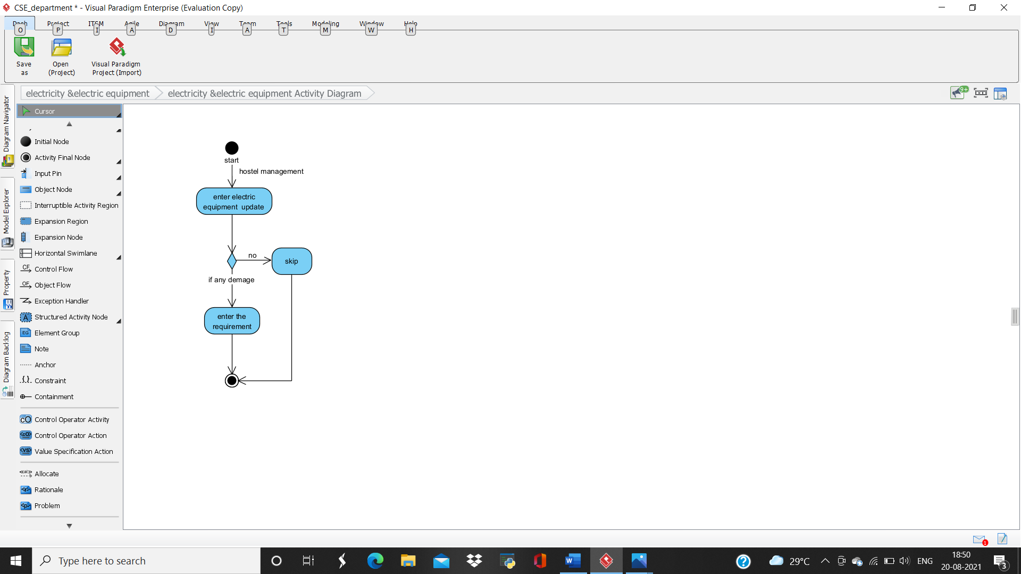

**• ACTIVITY 6**

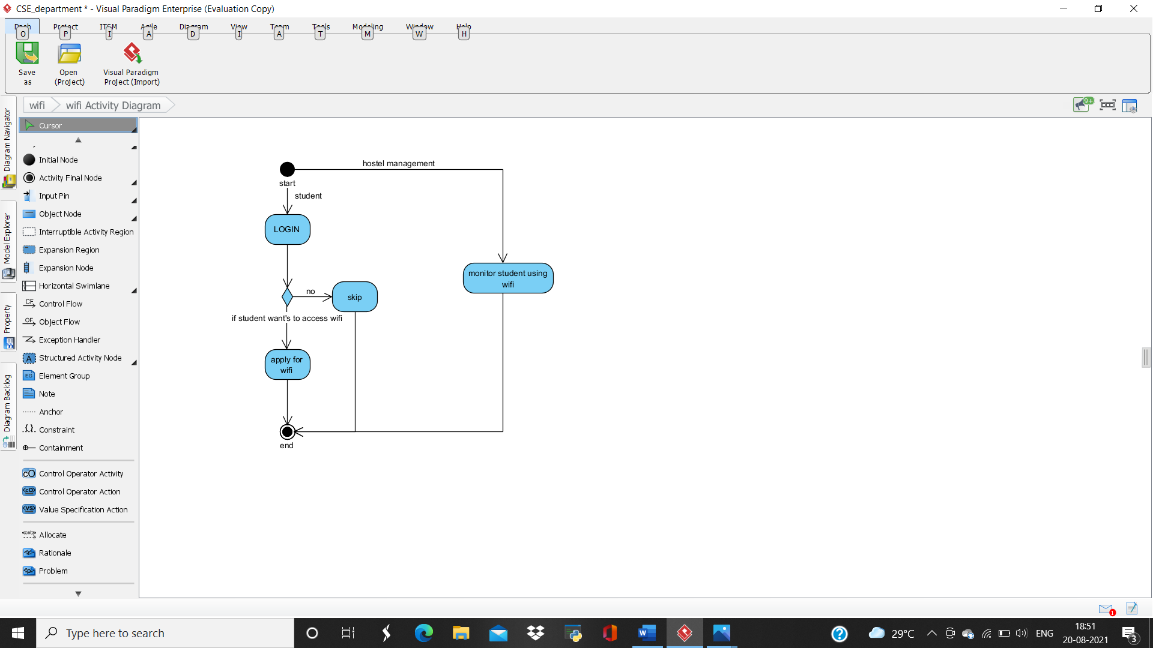

**• ACTIVITY 7**

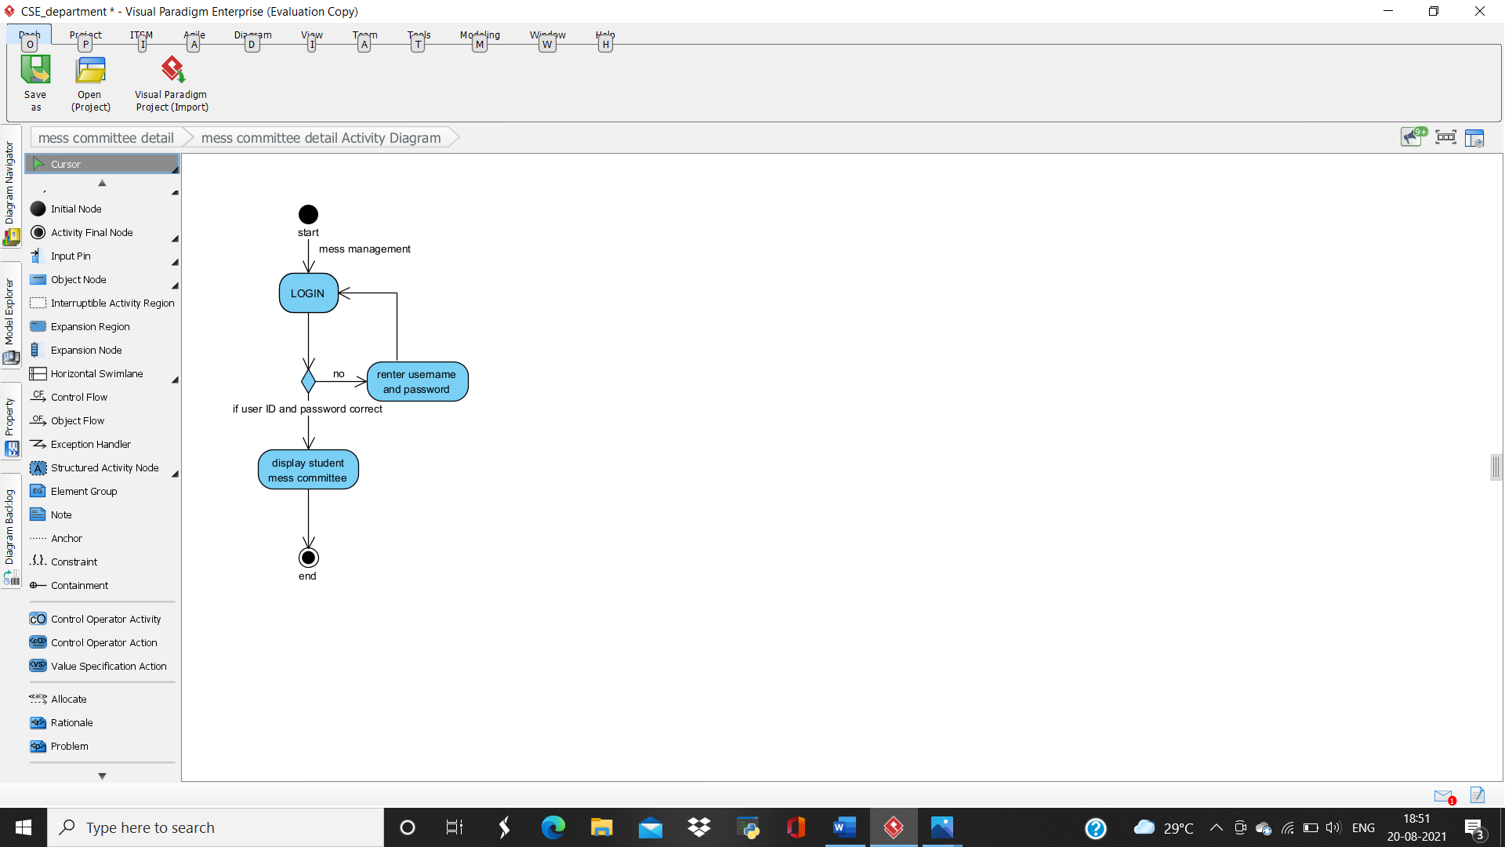

**• ACTIVITY 8**

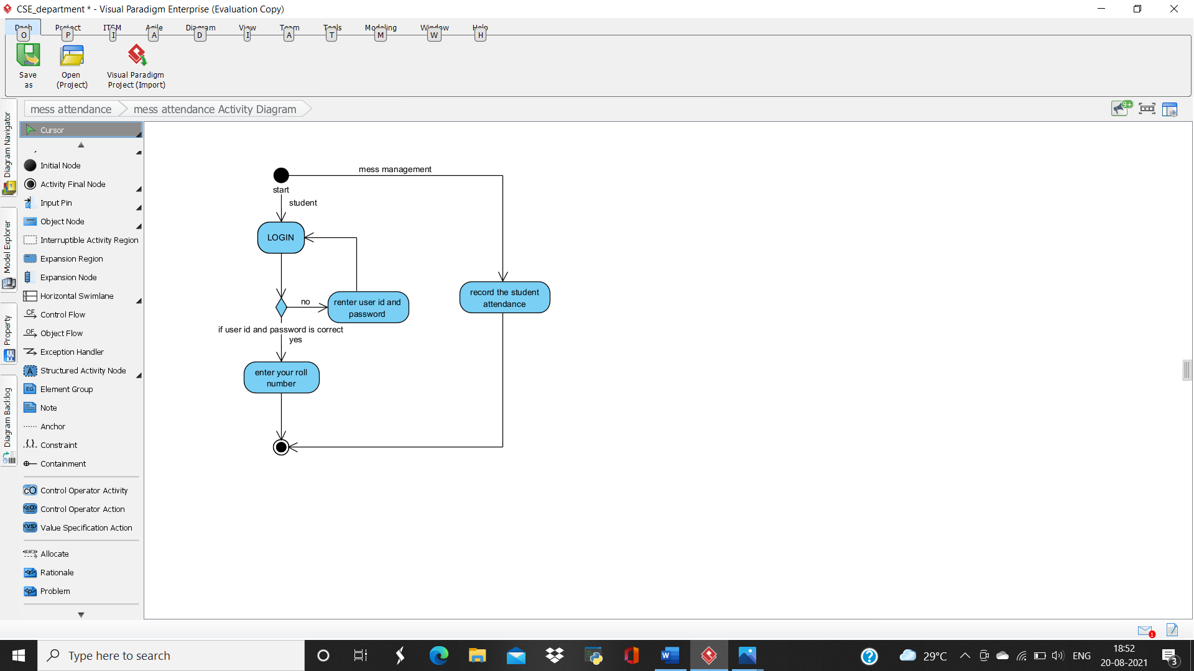

**• ACTIVITY 9**

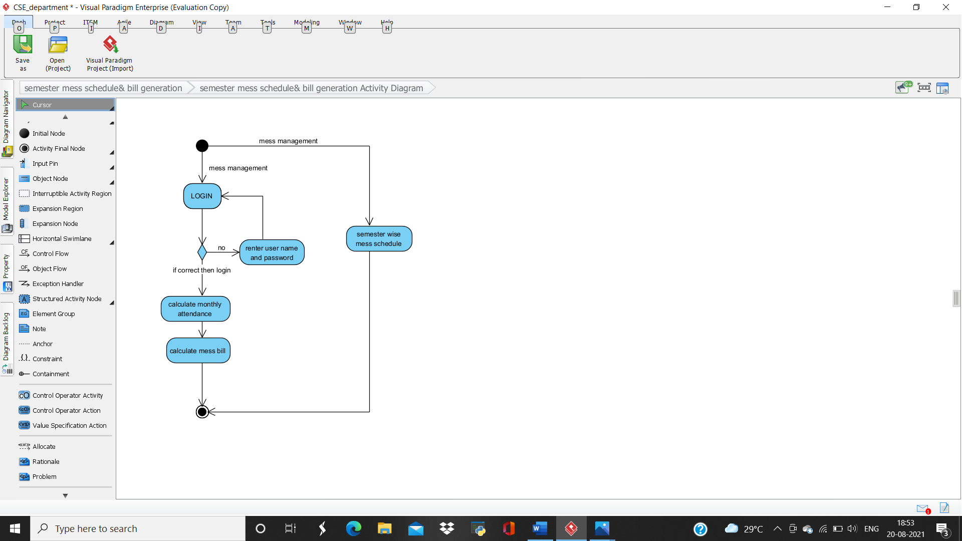

**• ACTIVITY 10**

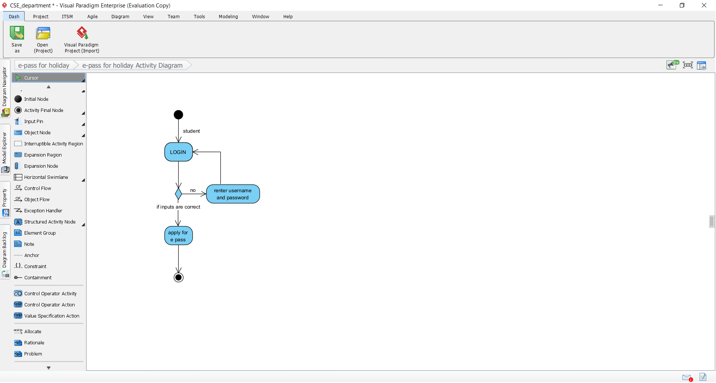

**• ACTIVITY 11**

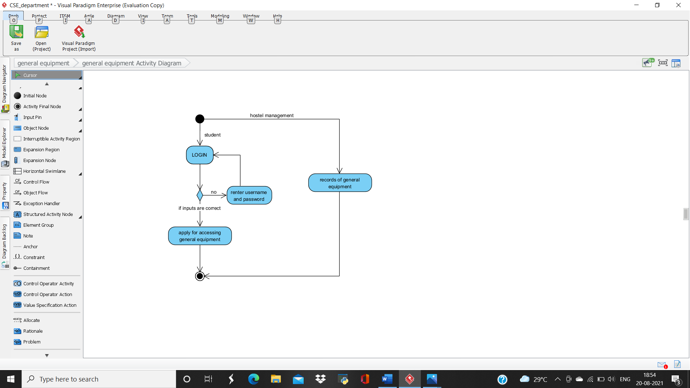

**• ACTIVITY 12**

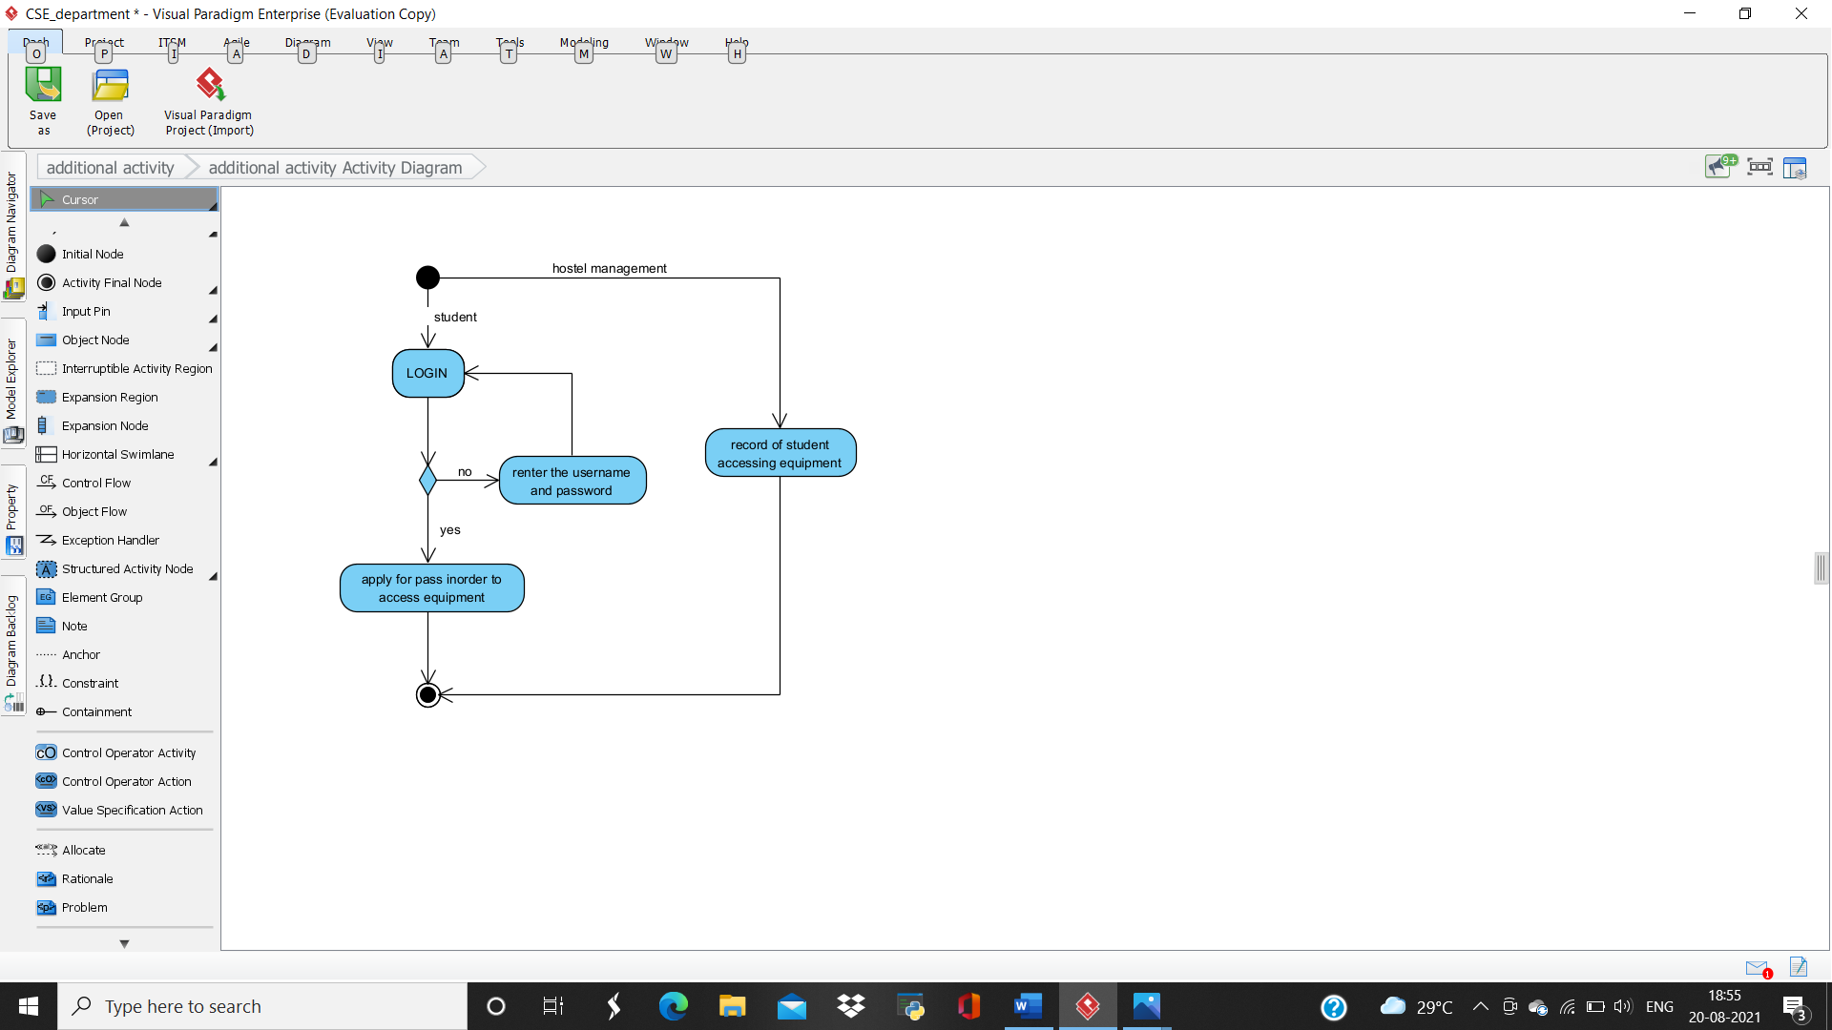

**• ACTIVITY 13**

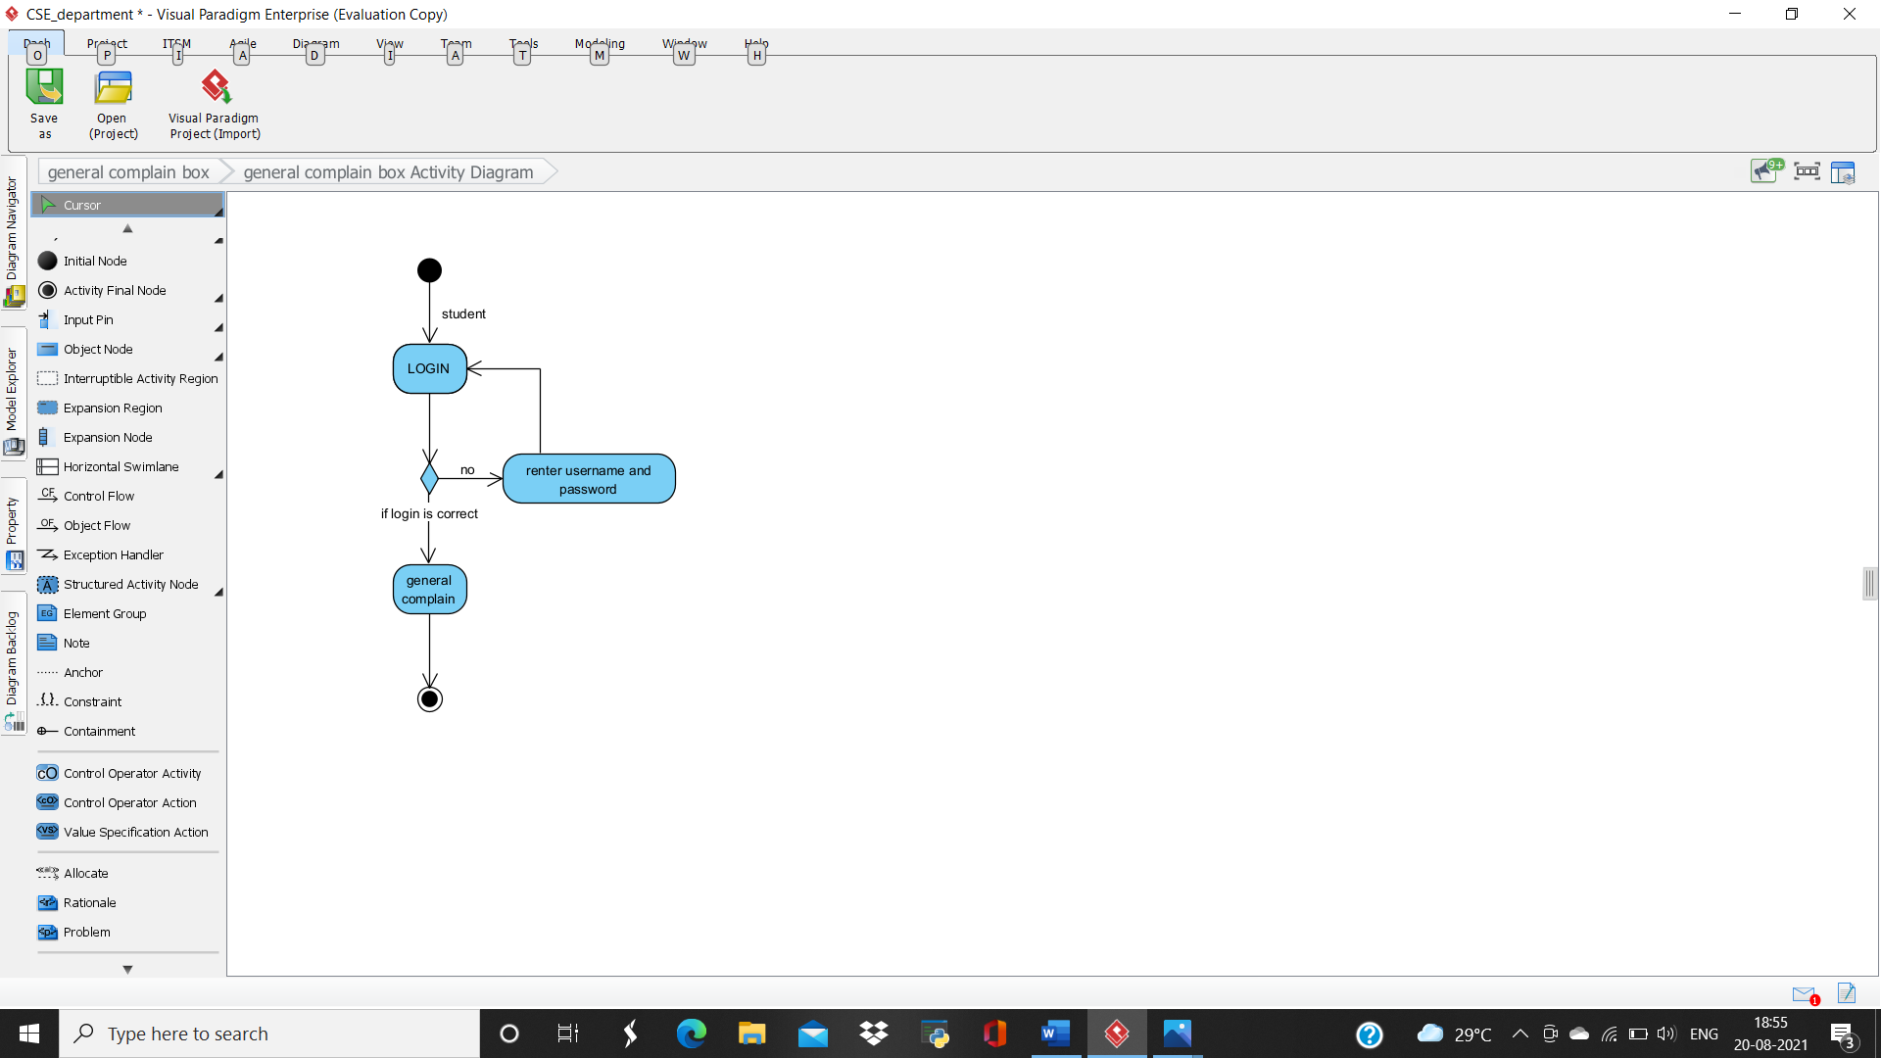

**• ACTIVITY 14**

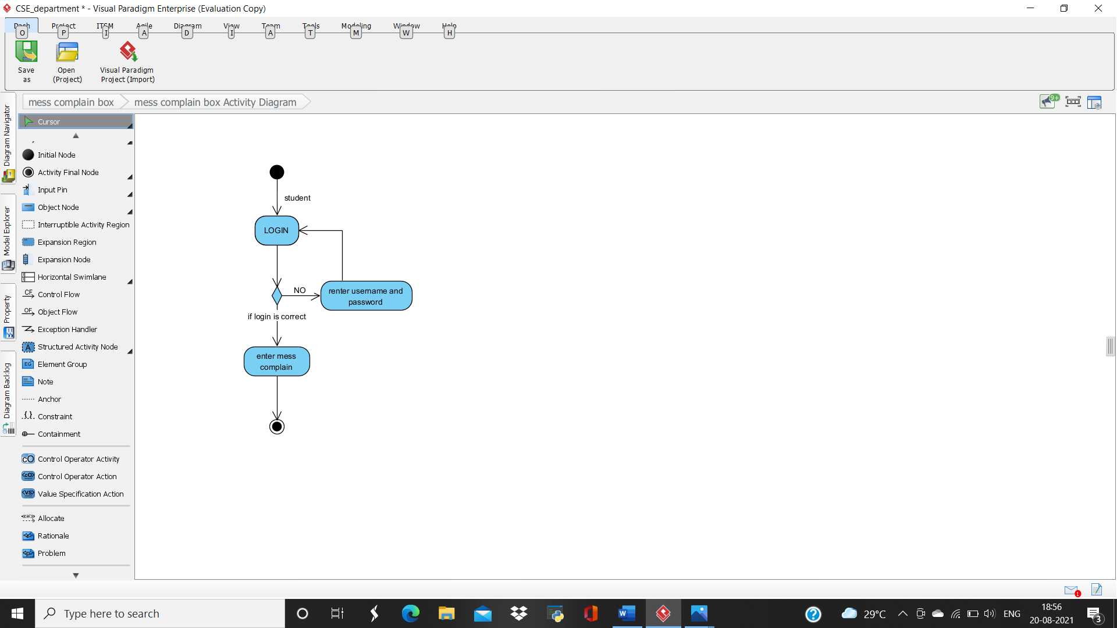

**MODULE 4: EXAMINATION DEPARTMENT**

**#REQUIREMENT**

* **Requirement 1: Scheduling of examination**
* **Requirement 2: Timetable of exam**
* **Requirement 3: Generating admit card**
* **Requirement 4: Question paper printing**
* **Requirement 5: Unique code printing in answer sheet**
* **Requirement 6: Calculation of G.P.A**
* **Requirement 7: Result generation**
* **Requirement 8: Scheduling of invigilator during exam**
* **Requirement 9: Number of students passed PDF**
* **Requirement 10: Number of student failed PDF**
* **Requirement 11: Scheduling of backlog examination**
* **Requirement 12: Result generation for backlog**
* **Requirement 13: Grade provision to student**

**#FUNCTIONAL REQUIREMENT**

* **Requirement 1: Scheduling of examination**

**Description:** **This following portal will have where admin can decide number of exams to be held per semester. This will also have form of exam to be conducted during semester.**

* **Requirement 2: Generating admit card**

**Description: This following portal will have a admit card of student which will be eligible for examination hall. It will have details of student and the subject name they have opt for the following semester.**

* **Requirement 3: Question paper printing**

**Description: This following portal will be applicable only for teachers and examination department where teachers have to upload the question paper and examination department have to print it according to the strength of students who are appearing in the following subject.**

* **Requirement 4: Unique code printing in answer sheet**

**Description: this portal is for exam department where they will have to print unique code for student answer sheet and every subject will have different code in their answer sheet. Besides this, update of unique code will help in sequence to keep answer sheet for anyone claims for re-evaluation. This will also help in not mixing up with others student answer sheet.**

* **Requirement 5: calculation of G.P.A**

**Description: this portal will help student to calculate their S.G.P.A. it is the portal where student have to enter the G.P.A marks and they get marks in a percentile form.**

* **Requirement 6: Result generation**

**Description:** **This portal is for teachers use. Where they can input the marks of students and further lock it so that student can see their marks.**

* **Requirement 7: Scheduling of invigilator during examination**

**Description: This portal will help the admin to input the allotted duty for teachers in particular examination hall.**

* **Requirement 8: Scheduling of Backlog examination**

**Description: This following portal will have where admin can decide backlog exams to be held per semester. This will also have form of exam to be conducted during semester.**

* **Requirement 9: Result generation for backlog**

**Description:** **This portal is for teachers use. Where they can input the marks of students and further lock it so that student can see their marks whether they have cleared the following subject.**

* **Requirement 10: Grade provision to student**

**Description: This portal will have the grade section so that student can understand the level of improvement they have to done and the requirement of more improvement.**

**•Requirement 11: Timetable of exam**

**Description: this portal will show the scheduling of subjects to be held with date and time in a particular examination.**

* **Requirement 12: Number of students passed PDF**

**Description: This portal will have the PDF copy of all student who have passed their semester exam successfully.**

**• Requirement 13: Number of students failed PDF**

**Description: This portal will have the PDF copy of those students who could not pass in the particular subject.**

**#USE CASE DIAGRAM**

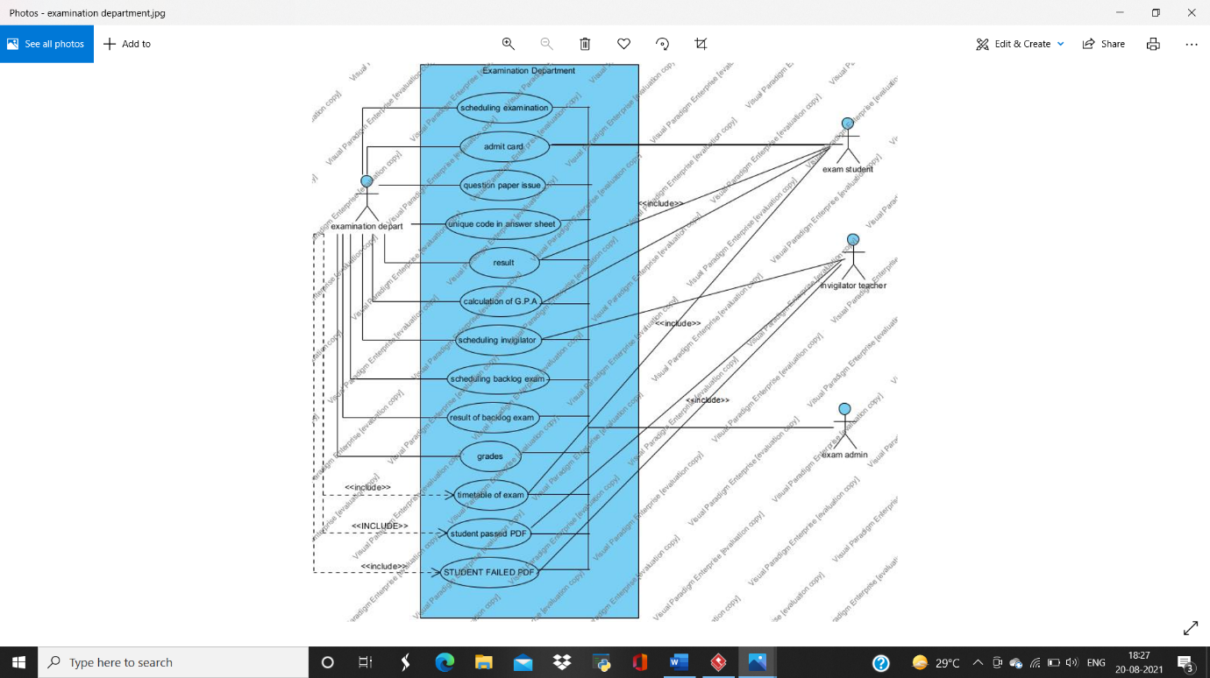

**#ACTIVITY DIAGRAM**

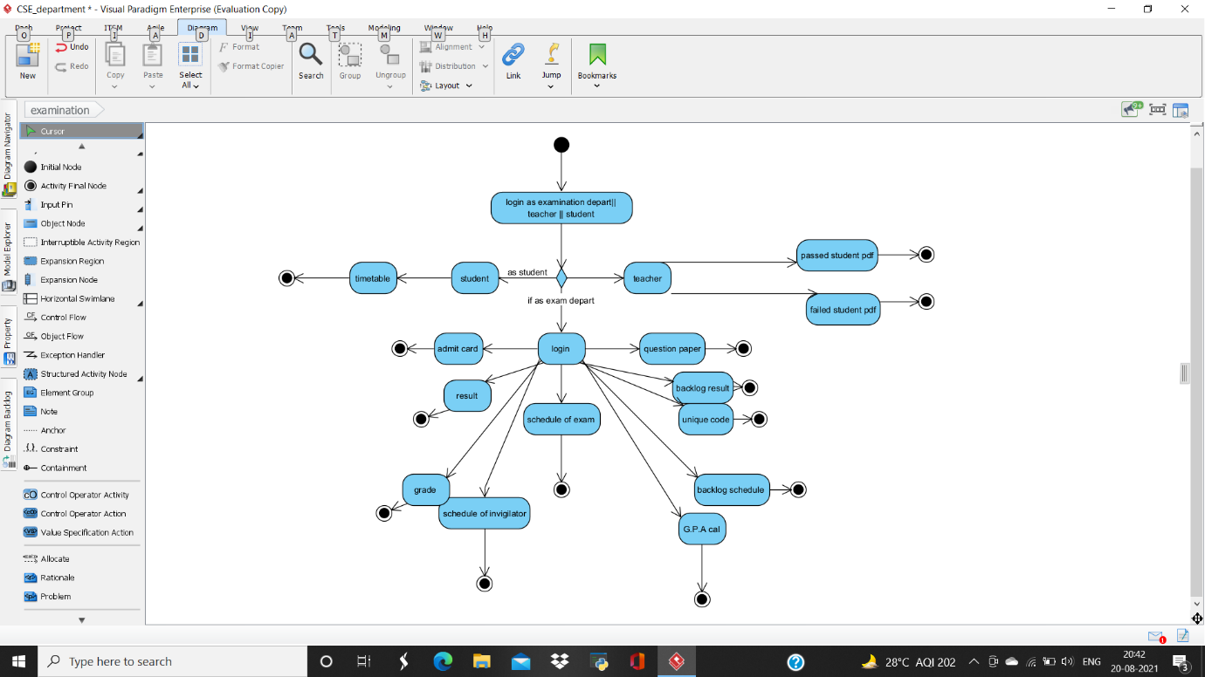

**• ACTIVITY 1**

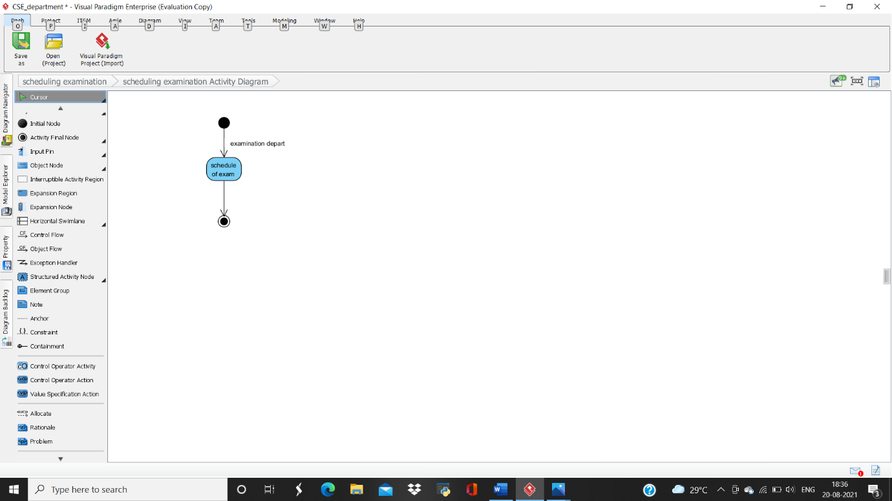

**• ACTIVITY 2**

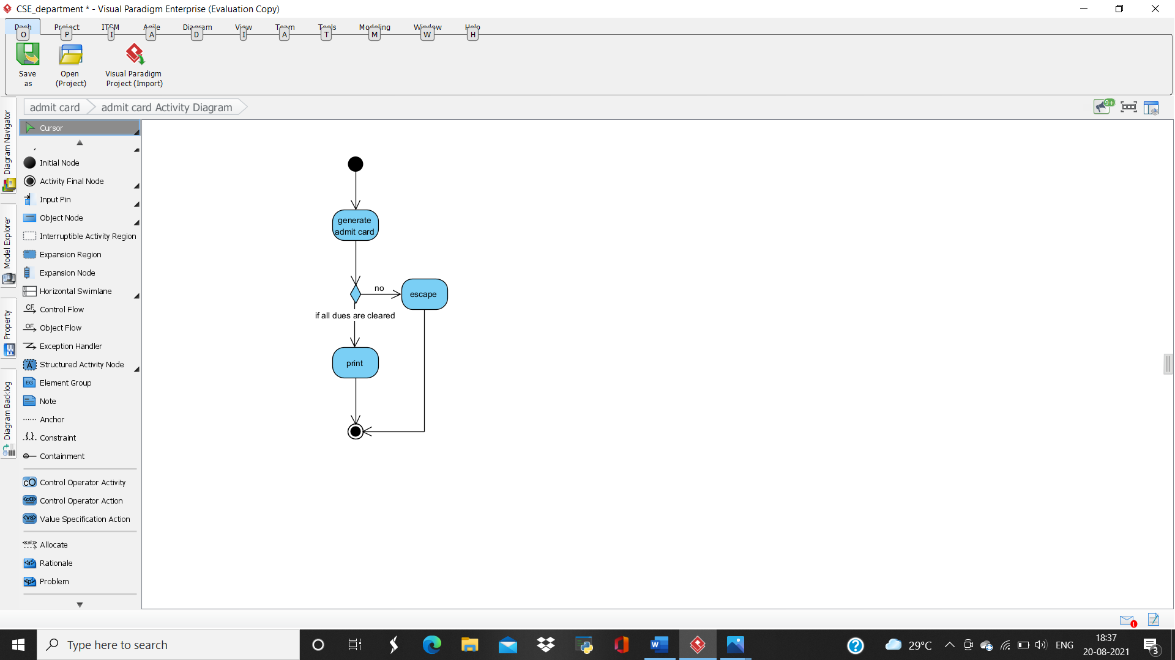

**• ACTIVITY 3**

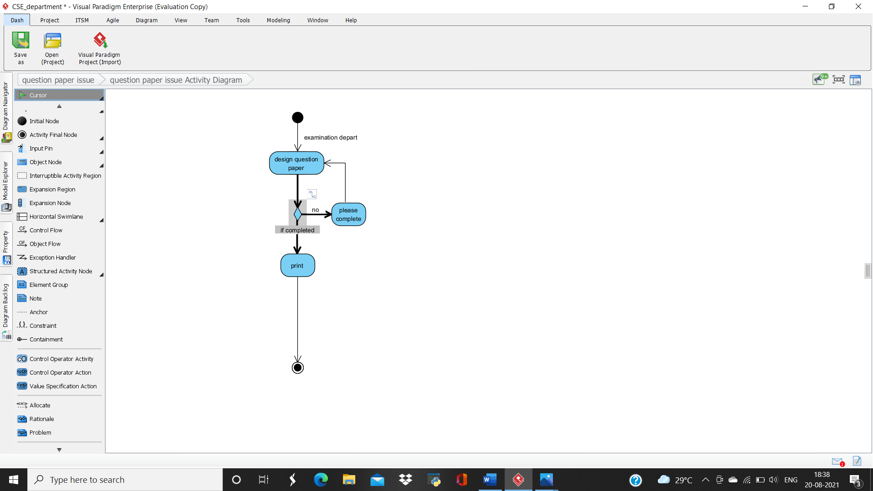

**• ACTIVITY 4**

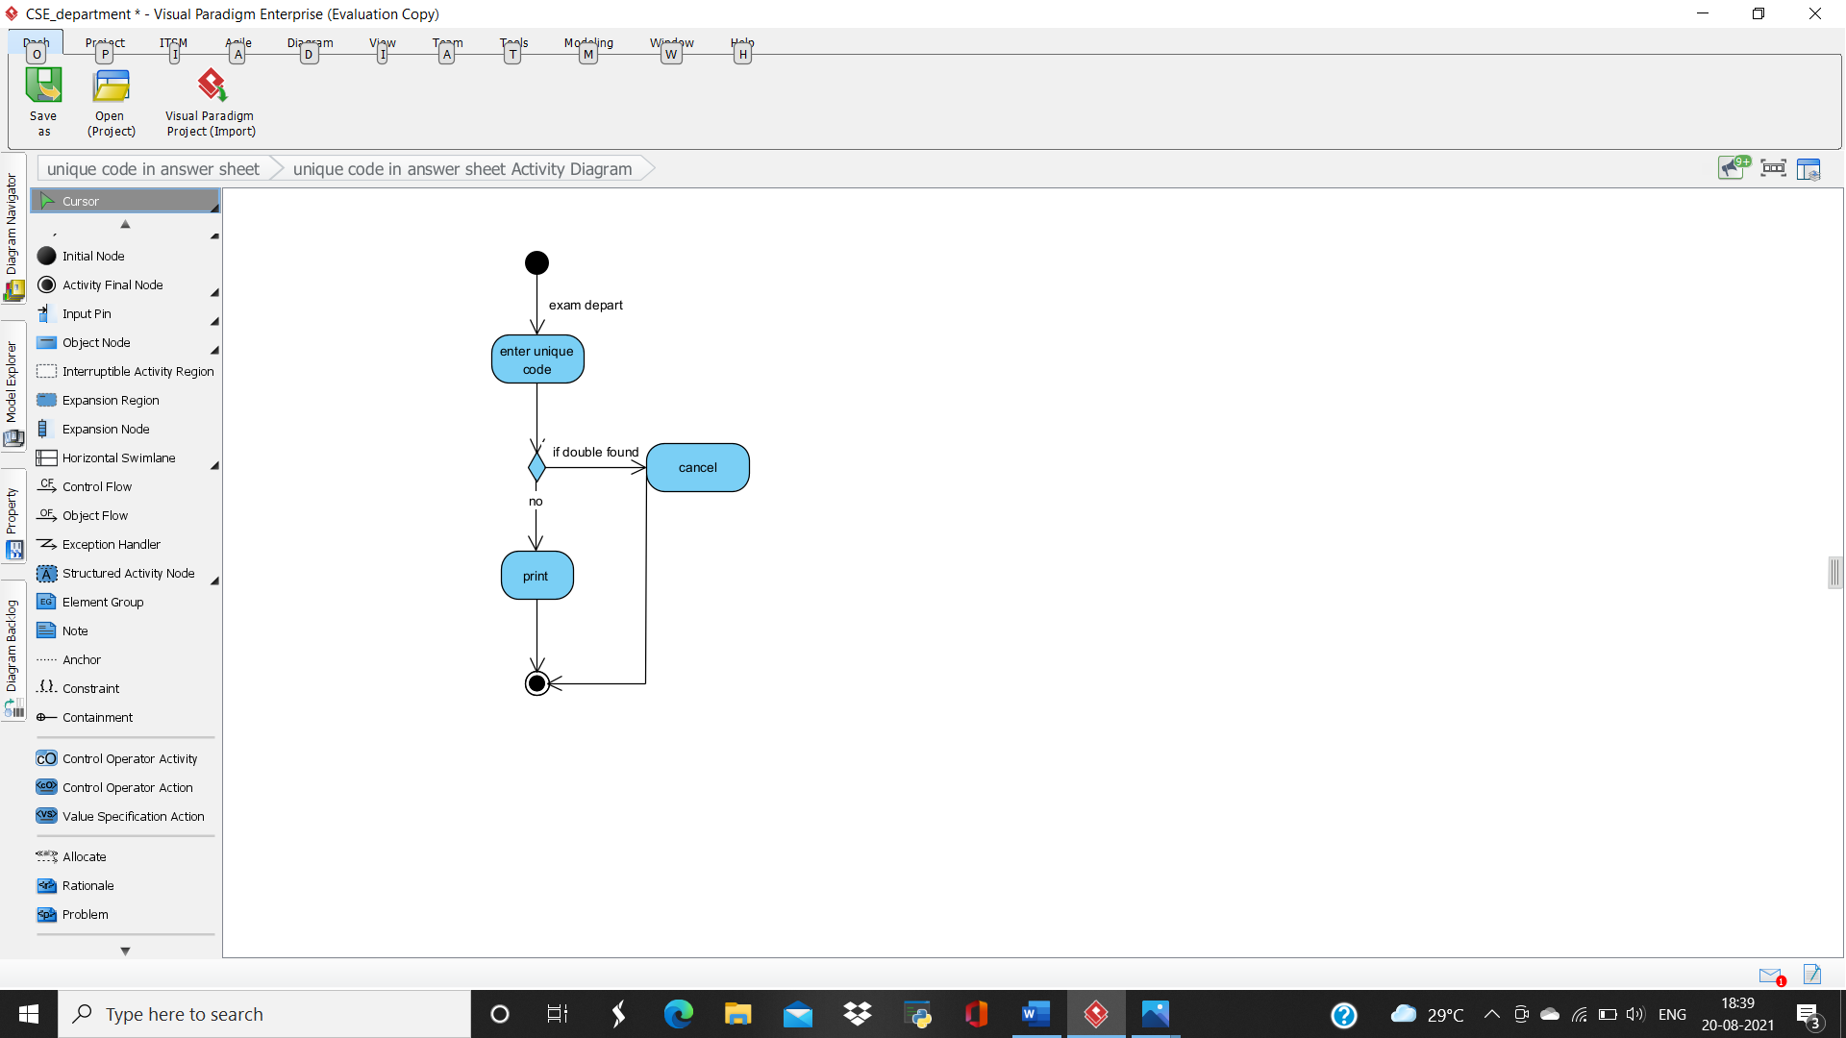

**• ACTIVITY 5**

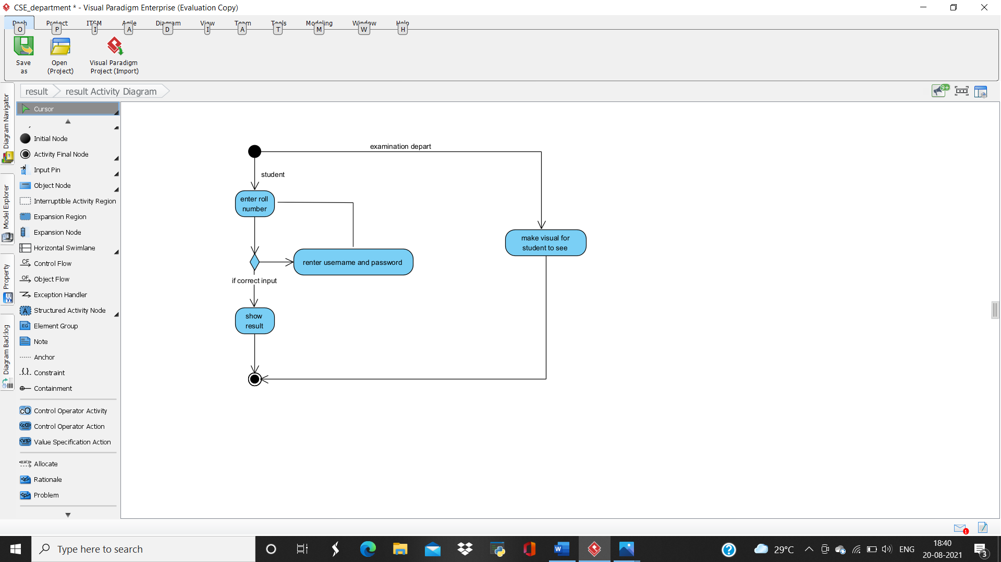

**• ACTIVITY 6**

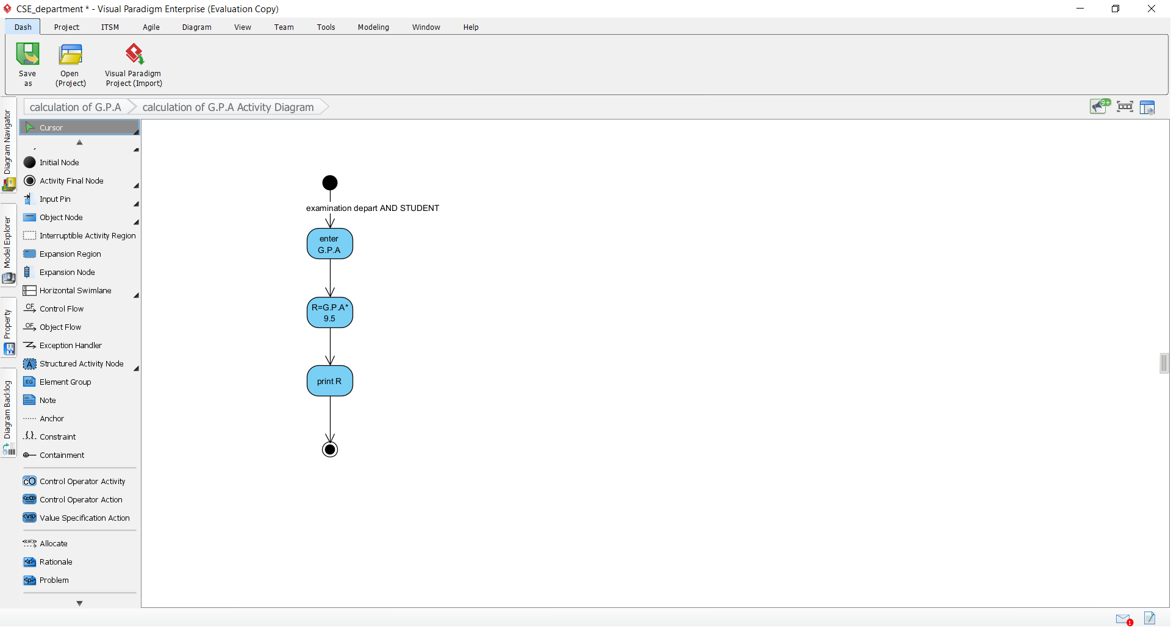

**• ACTIVITY 7**

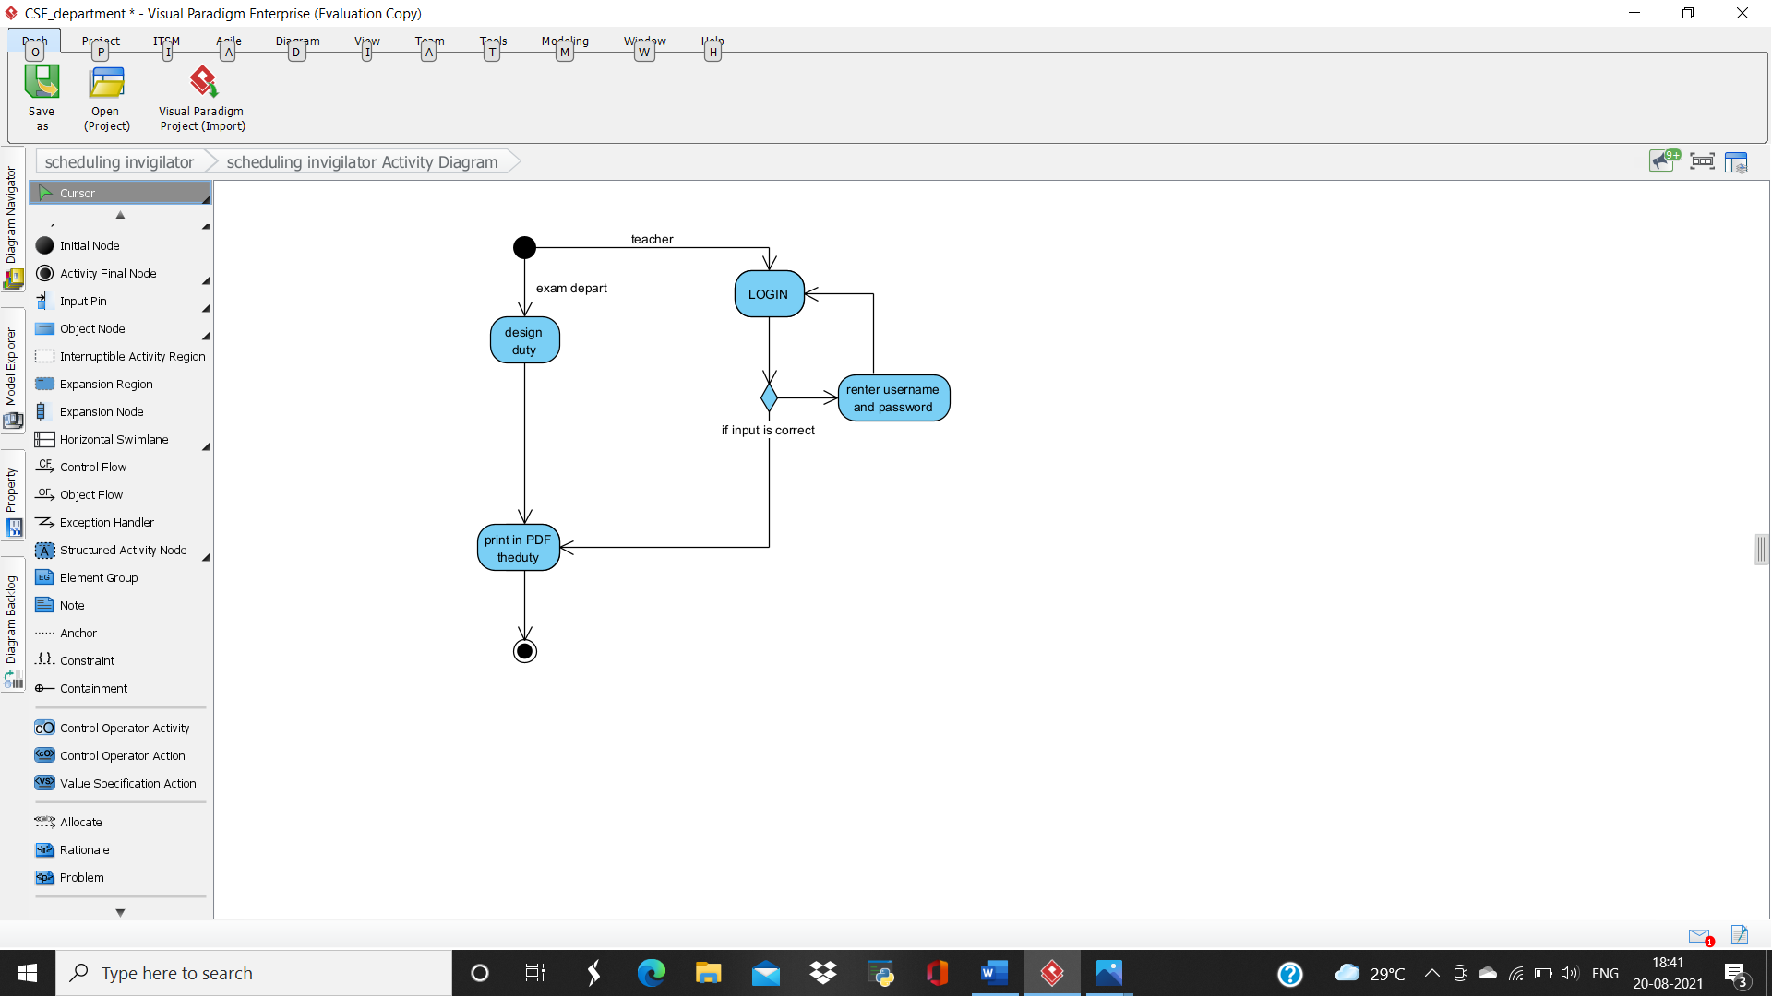

**• ACTIVITY 8**

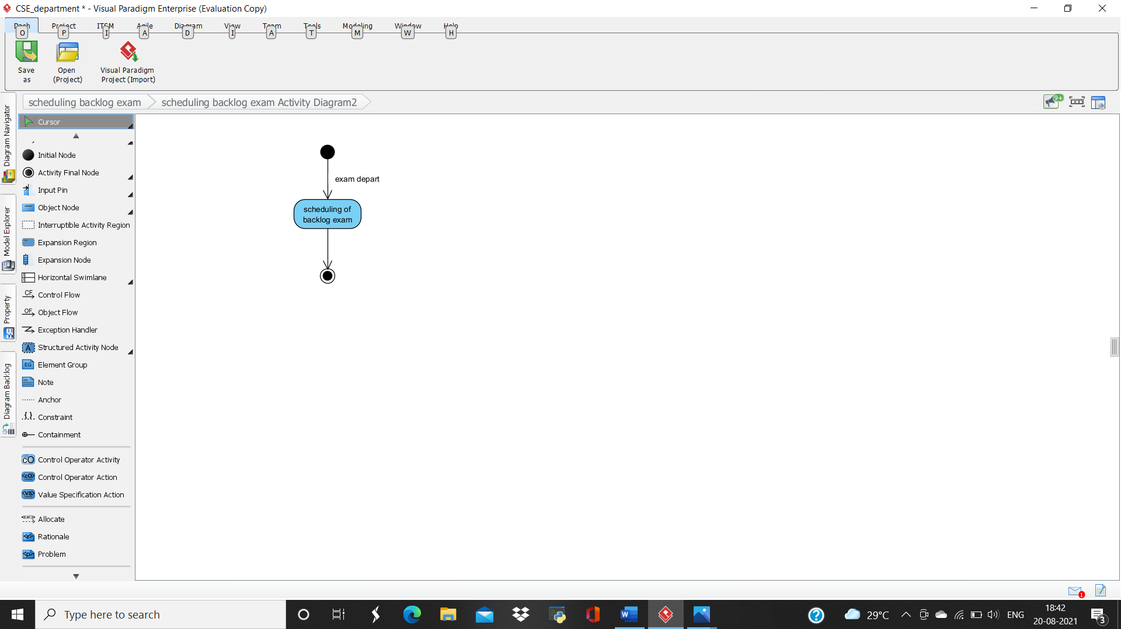

**• ACTIVITY 9**

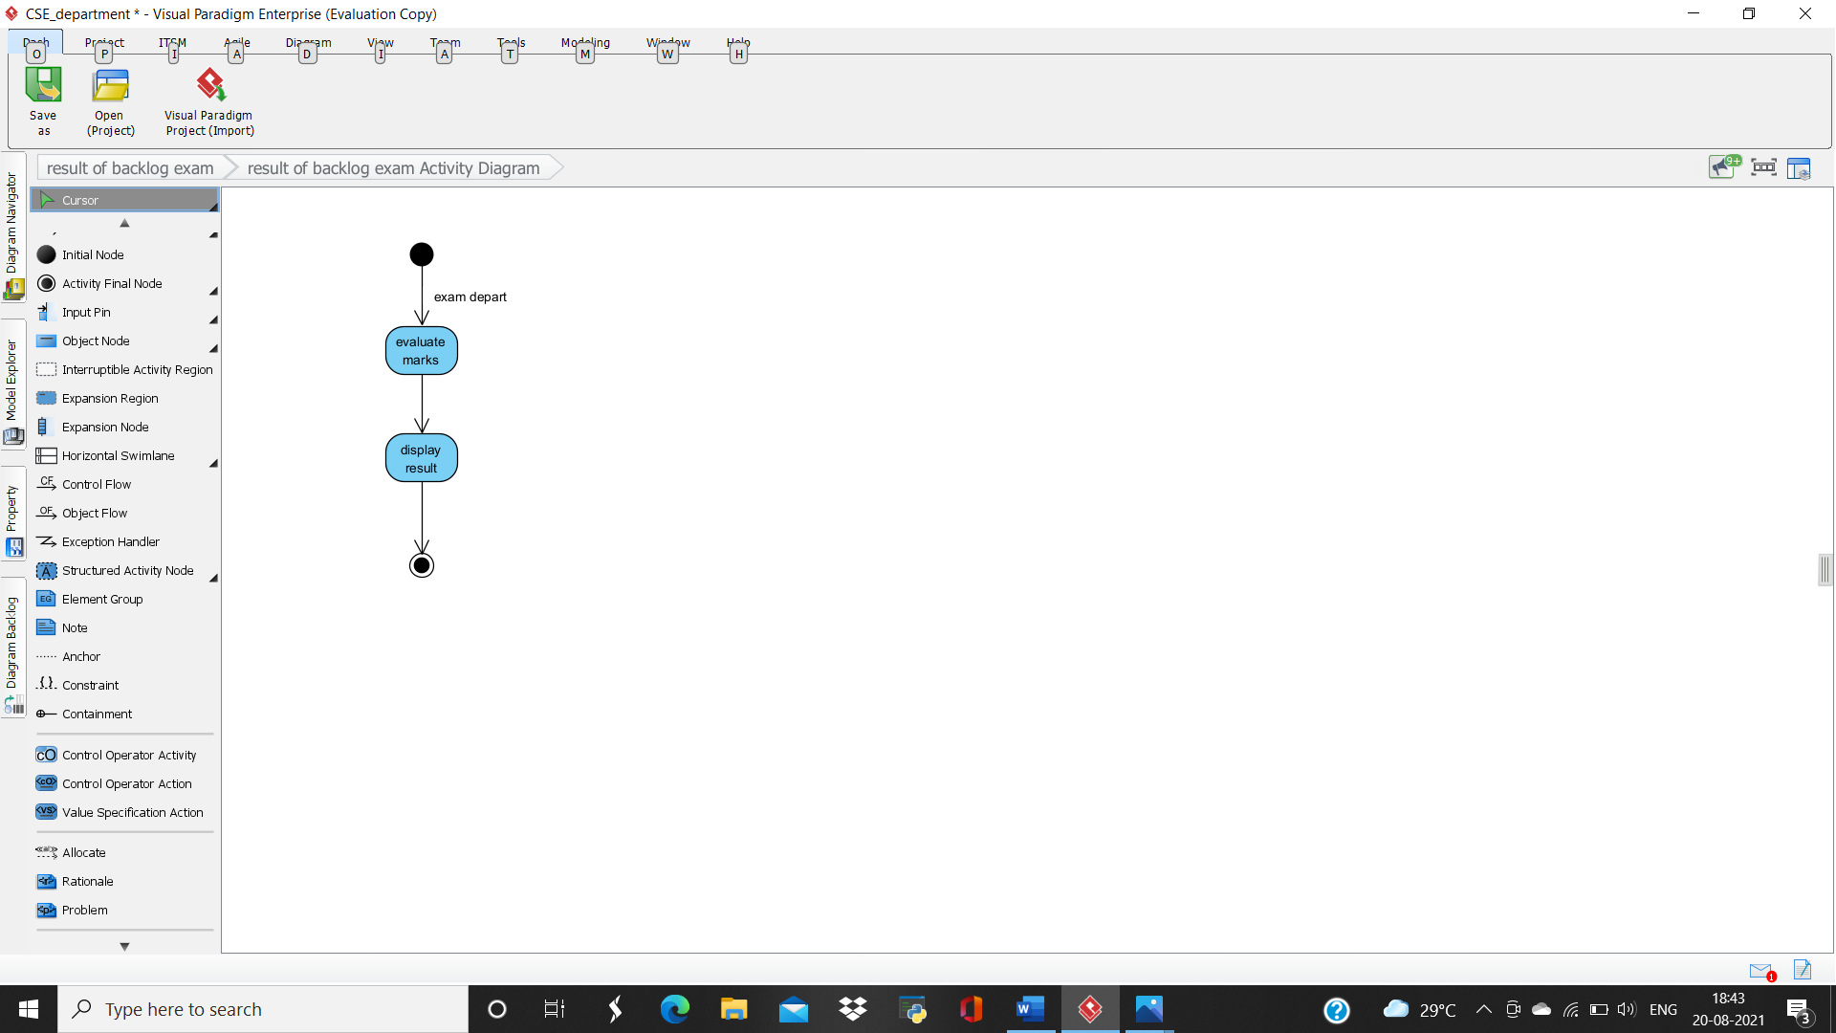

**• ACTIVITY 10**

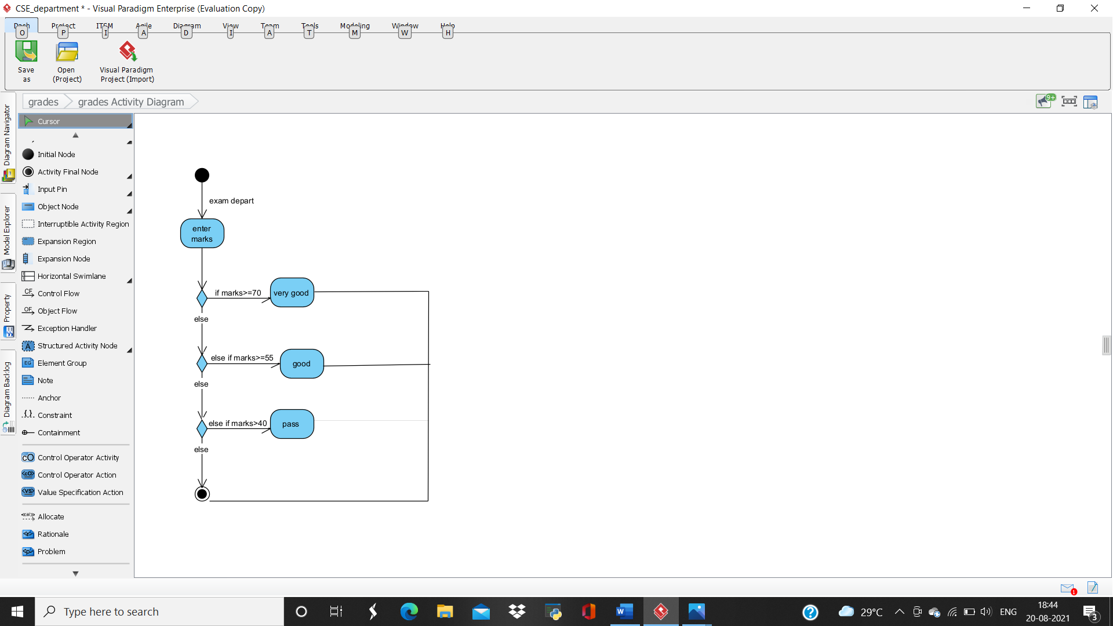

**• ACTIVITY 11**

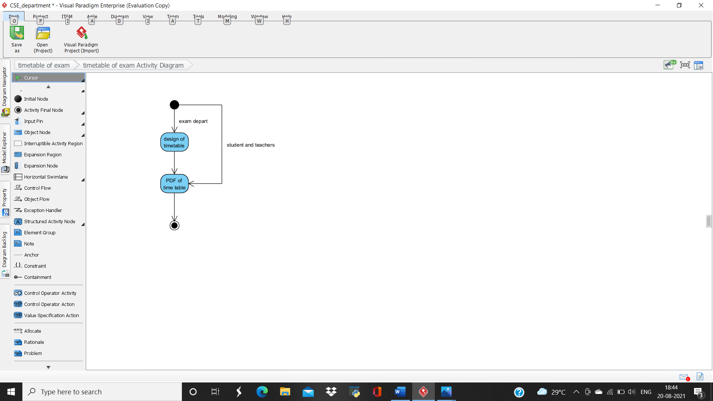

**• ACTIVITY 12**

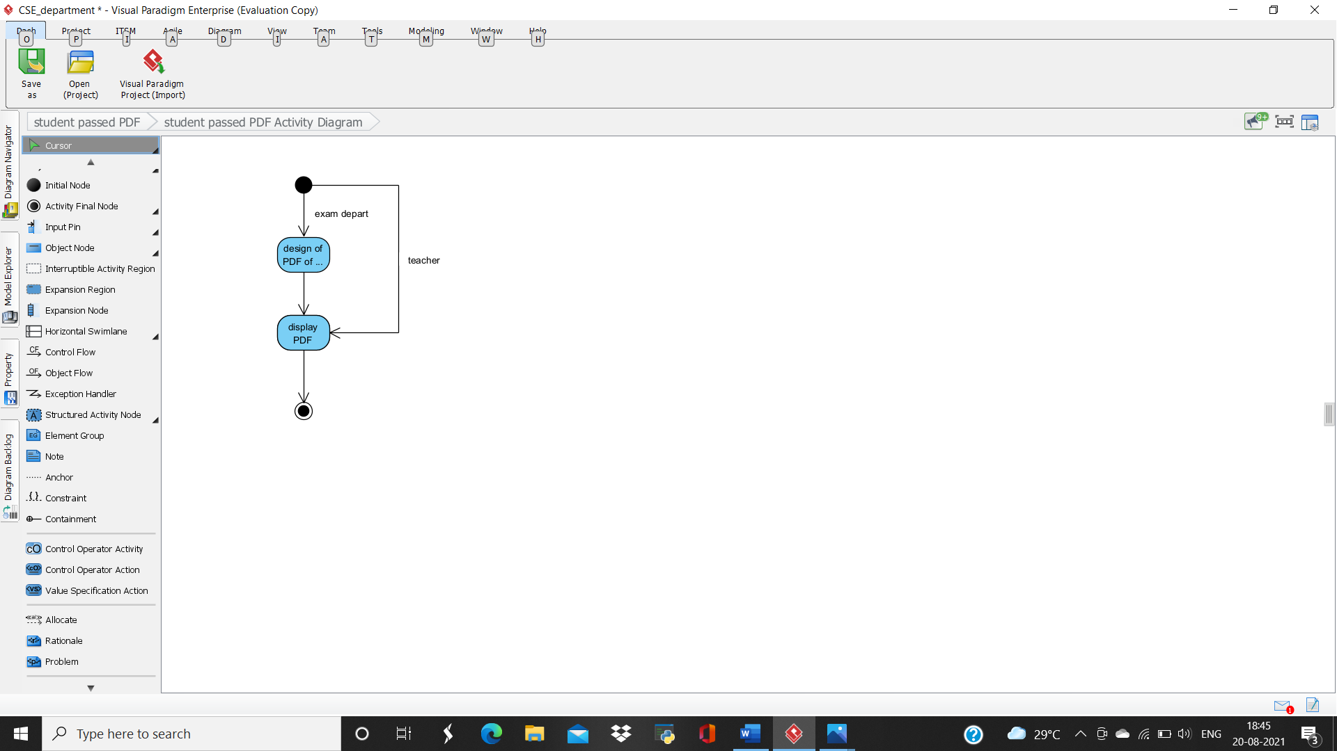

**• ACTIVITY 13**

